Training Session Outline
Pro-Safe Sport

Time: 8 hours 45 minutes including breaks
Number of Participants: 12-26 (preferably even number)
Facilitation: The facilitation of the workshop requires pedagogical competencies. The facilitator should understand the potentials of this collective learning process, should be able to provide the necessary dynamics for the group and should be able to facilitate the process to ensure the expected learning outcomes of the participants. Ideally the workshop should be facilitated by trainers experienced in non-formal education and preferably in education through sport.
The aim of the workshop is to support stakeholders of sport organisations in developing a safe environment for young athletes in high performance sports in Europe.
Target group – participants of the workshop
Administrators, management staff of sport organisations at international, European and national level. The workshop is designed for those staff members or board members of sport organisations who have the responsibility and power to implement the policy and system of a safe (physical, psychological, social and fairplay) environment for young athletes.
Objectives of the workshop
- To increase the level of understanding of the principles of pro-safe sport for young athletes,
- To provide an opportunity to reflect on one’s own skills and capacities to implement pro safe sport strategies,
- To enable participants to use the PSS toolkit in further developing skills and capacities in creating safe environments for young athletes,
Expected learning outcomes
- Understanding the concept of pro-safe sport
- Learning about the different aspects of pro-safe sports
- Becoming familiar with the European policy measures of pro-safe sports
- Understanding the role of their sport organisation in creating pro-safe sport environment
- Identifying their own role in creating pro-safe sport environment in their organisation
- Becoming able to assess their organisation in light of pro-safe sport principles
- Becoming able to advocate for pro-safe sport environment
- Becoming able to identify priority areas for improvement in their organisation
- Being able to use the Toolkit for their further work in creating pro-safe sport environment
- Being motivated to explore the topic further by using the toolkit and other relevant resources
- Becoming committed to pro-safe sport principles
Content of the workshop
- Pro-safe sport approach
- Themes and categories of pro-safe sport
- EU, CoE and IOC policies
- Assessment grid
- Toolkit
- Video films
- Practice examples
- Method of identifying priorities for action
Methodology of the workshop
The workshop is based on non-formal education methodology. The participants are actively involved in the process of the workshop. They participate in the activities by expressing their thoughts and ideas, by exchanging their practices, by sharing their ideas and values and by cooperating in the exercises. The workshop is concluded with reflection and evaluation by the participants.

The Pro Safe Sport Cycle

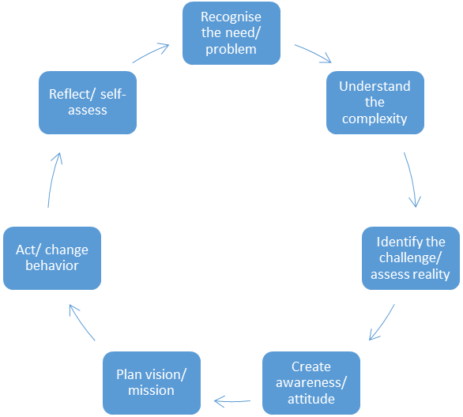

Flow of the workshop
Time required | Activity | Guidelines for facilitator
DAY 1
20 minutes | Welcome and introduction  Welcoming the participants. Icebreaker and getting to know each other exercise.  The longer video film is shown to participants as an introduction to the theme. | Projector, internet
15 minutes | Getting close to the topic „Pro Safe Sport – safe and healthy sport environments“  Participants are asked to think back and identify a moment in their sport life when they felt that the environment was very safe. Think of the situation or incident and find out the reasons why you felt safe.  Think back and find a situation when you felt unsafe. Find out why you felt unsafe.  Participants are asked to share their thoughts in pairs.  OR:  15 minutes  Read individually/ in groups the articles which can be found in the toolkit section “master presentation - articles”.  30 minutes  - Summarize and present the contents of the article in the plenary.  - Discuss the following questions in the plenary:  -- Which challenges are raised in the article?  -- How can this challenge be best met?  -- What can my organisation/ I learn from this example? | Sensitivity to personally experiences. Disclaimer shall be announced that all information shared by participants should be handled with respect and confidentiality.
30 minutes | Getting close to the topic „Pro Safe Sport – safe and healthy sport environments“  Participants are asked to write positive and negative components of safe environment on post-its (based on the previous discussions in pairs). One element on one post-it. All post-its are put on the wall and the group discusses them and puts them into the 4 categories that are described by the facilitator (see on the right). | Categories:  Physical (components that ensure body safety and body health)  Psychological (components that ensure mental integrity, open mind and psychological balance)  Social (components that ensure positive collective atmosphere, cooperation, respect, trust, equal opportunities and solidarity)  Fairplay (components that ensure the cleanness of the game, the respect of rules, transparency and fair participation)
15 minutes | Informing and raising awareness  Facilitator presents the overview about EU, CoE and IOC policy developments in relation to pro-safe sport. Participants can comment or ask questions. | See the Toolkit section on policy update.
75 minutes | Experiences with Pro Safe Sport in a sport federation/ stakeholder organisation – do´s and don´ts  - Guest speaker  Taking a look at what others have done  - Participants are organised into 4 groups. Each group is given one practice example with the following questions:  - How is pro-safe sport ensured in this practice example?  - What are the strengths of this practice?  - How could you improve it?  Each group is requested to present their practice and their answers to the whole group. | 15-30 minutes including Q&As  10 minutes introduction, 20 minutes group work, 20 minutes presentation of results, 10 minutes conclusion  Select the 4 most relevant practice examples from the Toolkit section with practices.
75 minutes | Self-Evaluation of the situation in the federation  Facilitator introduces the Assessment Grid of the Toolkit. Each participant is asked to fill in the assessment grid of the Toolkit individually. The Grid can be filled on paper or online.  The facilitator explains the approach how to identify priorities for action. Participants are asked to rank the importance of the components.  Participants are organised into groups of 3-4. Each group member shares his/her identified priorities for action and other group members comment or advice on potential actions. | 10 minutes introduction, 20 minutes filling the grid, 30 minutes for sharing, 15 minutes concluding
DAY 2
30 minutes | Presentation of the Pro Safe Sport toolkit  Facilitator presents the online Toolkit. The different tools are introduced with the help of projector. Practice examples, the workshop template, glossary, collection of resources, Assessment Grid, video films.  Participants are asked to explore the different tools.
60 minutes | Developing a specific action plan  Develop a specific action plan to implement pro safe sport in my organisation  Rating through the participants:  In your opinion - what are important aspects of a safe and healthy sport environment? Write down up to three of the most important!  Rate on a scale of 1 (no need or willingness to deal with the topic in your federation) to 10 (urgently needed or very high willingness):  Where would you set the point for your federation? (Discussions can be based on the self-evaluation)  Presentation of the action plans | Group of 2 work together on each other’s action plan  40 minutes  20 minutes
45 minutes | The importance of safe and healthy sport environments  Closing activity. A Carousel exercise.  Explain the importance/ action plan of pro-safe sport to  - your colleague,  - your boss,  - your board member,  - one of your coaches,  - one of your young athletes,  - one parent of an athlete.  Then the facilitator debriefs the exercise with the participants with the following questions:  - Was it difficult to explain to the roles?  - Was there any interesting, or convincing advocate, if so what?  - Which was the most difficult? Why?  - What could work and what would not?  - What would you do differently?  The facilitator highlights some of the most important conclusions. | Half of the participants are asked to form a circle facing outward the circle. The other half of participants stands facing one of the circle persons. (Equal number in inner circle and outer circle). There should be about 1 meter between each couple so that they do not disturb each other when talking. First the inner circle takes up the role that is given by the facilitator and listens, and the other circle explains, then the other circle steps one person forward and they switch the outer circle will take up the role and listen and the inner circle explains. End it goes on 6 times as there are 6 roles provided. Each explanation takes 3-4 minutes.  5 minutes forming the circles, 25 minutes for the 6 rounds of explanation, 20 minutes debriefing and conclusions
15 minutes | Short evaluation of the workshop  Evaluation activity  Questions to be asked by facilitator:  - Do you understand what pro-safe sport is?  - Do you consider pro-safe sport environment a priority in your organisation?  - Are you motivated to start up improving the conditions for pro-safe sport in your organisation?  - Did you like the flow of the workshop?  - How did you like the facilitation?  Participants can also add a few more questions that they would like to evaluate with the group.  Facilitator concludes and closes the workshop and expresses thanks to the participants and relevant stakeholders. | Participants are asked to stand in a circle. As the facilitator asks the question they must express their opinion by standing in certain distance from the centre of the circle. If one stand sin the middle of the circle it means that he/she found that aspect very positive, if one stands far from the centre of the circle it means he/she disliked that aspect of the workshop. Facilitator asks some of the participants to explain why they stood there after each question.

