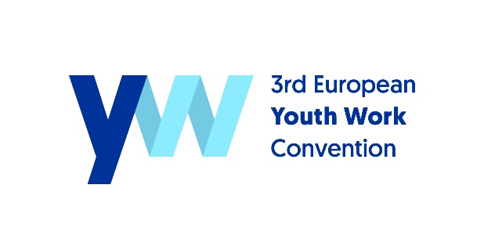
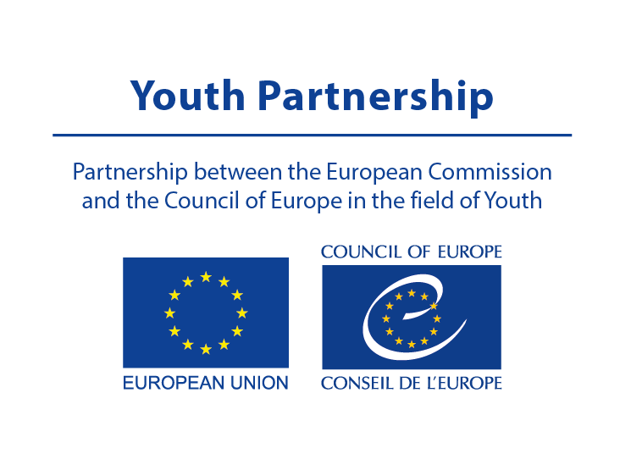

Perspective on Youth Work Developments
Country____________ FACT SHEET
Please submit a completed fact sheet for your country to youth-partnership@partnership-eu.coe.int by 15 December 2020
The 3rd European Youth Work Convention (EYWC) plays a key role in launching the implementation of the European Youth Work Agenda (EYWA) as a strategic framework for further developing and strengthening youth work practice and policies in Europe. The goal of this fact sheet is to provide basic information about the perspective on youth work developments in a specific country. All information has been gathered from national contact points, reports or country sheets and profiles available online. The purpose of this fact sheet is to stimulate discussion before, at and after the 3rd EYWC among the members of the national delegations. This information is a suggestion only and a starting point for further development by the delegation when planning actions for implementation of the EYWA.

FACTS
Youth work as a recognised occupation:
Legislative framework for youth work:
Main youth work actors: (ministries, youth NGOs, municipalities etc.)

Highlights with regard to youth work development:

.

STRENGTHS & SUCCESSES | CHALLENGES

SUPPORT NEEDED

GREATEST NEED FOR FURTHER DEVELOPMENT OF YOUTH WORK IN THE NEXT THREE YEARS

ADDITIONAL SOURCES

