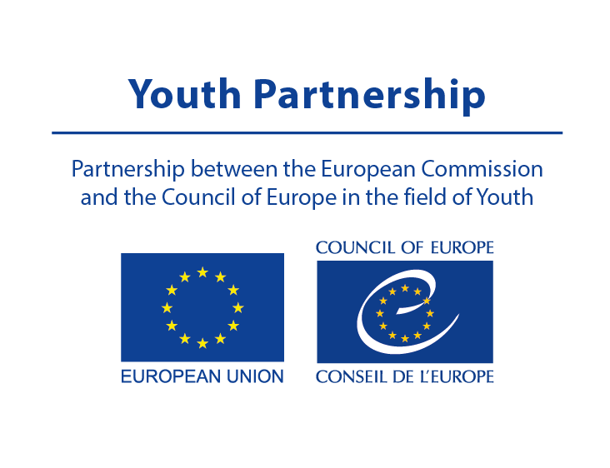

POOL OF EUROPEAN YOUTH RESEARCHERS (PEYR)
APPLICATION FORM

Please complete this form and send it, together with other supporting documents (CV and writing sample) to youth-partnership@partnership-eu.coe.int

Deadline for applications: 14 October 2020
First name:

Last name:

E-mail:

Your age:

Country of residence:

Nationality/-ies:

Level of confidence of working in English (written and oral):

If you are affiliated to one or more research institutions, please name them and indicate your degree of affiliation and their address:

What is your experience in youth research:

What is your experience in developing knowledge-based youth policies:

What is your experience in developing knowledge about youth work?

What are the areas of youth research you are interested in? Please just name them briefly.

What are the related topics you have covered in your research in the past year?

What is your motivation for being a member of PEYR?

Please include below links to any relevant research projects or your publications:

