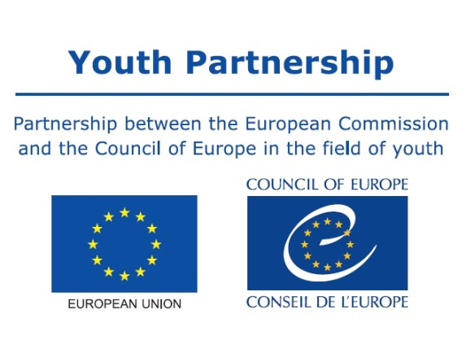
Mapping of recognition tools and practices

Form for contributions
Name or title of the recognition tool/practice:
Developed by:
Type of the tool/practice:  (please, choose all that apply) | Self-assessment tool  Assessment tool  Publication/Handbook  Video/Film  Event/Meeting/Seminar | Activity/Game/Exercise  Certificate/Attestation  Portfolio  Website/Platform/Blog  Other (please, explain):
Recognition dimensions:  (please, choose all that apply) | What aspects of recognition your tool/practice addresses?  Social recognition (refers to processes that lead to a better understanding and a more positive regard of the value of youth work and non-formal learning/education by others sectors and people from your community)  Formal recognition (refers to reaching an ‘official’ status for some aspect of youth work and non-formal learning/education, (e.g. validation of competences; official accreditation of programmes; certification of youth workers and trainers, etc.).  Political recognition (refers to the development of relevant policies (strategies, laws, etc.) around youth work and non-formal learning/education. It is also about putting youth work on the political agenda of the key institutions in your context.  Self-recognition (refers to better understanding of the value of youth work and non-formal learning/education by youth workers themselves and/or increased awareness of learning processes and outcomes by the young people participating in youth work activates)
Level of influence of your tool/practice: | What is the current level of influence of your tool/practice?  Organisational  Local/regional  National  International
Target group(s): | Who is the main target group(s) for your tool/practices?
Background and the context of development of the tool/practice. | Please, explain WHY have you developed it and HOW it all started?
Development process: | How did the whole development process go? Who was involved? What were the main steps in development of the tool/practice?
Objectives: | What were the main objectives of the tool/practice? What did you want to achieve?
Description of the tool: | Please, describe your tool/practice. How does it work?
Outcomes, results and impact. | Was there any evaluation of the tool/practice done so far? If yes or so far, what are the key achievements and results of your tool/practice? What is the impact of the tool/practice on recognition on non-formal education/learning and youth work in your context?
Links and references: | Please, provide links for further reference and more information about the tool/practice (e.g. web links, publications, etc.)
Contact details: | Who is the person who can provide more information about the tool/practices to the editors of the mapping study and the future readers?  Contact person:  E-mail:
Agreement with publishing the data: | Do you agree with publishing the data you have provided in the publication done by the EU-CoE youth partnership?  No  Yes

Please, submit filled in form, along with other relevant additional material (e.g. pictures, articles, samples of the material, video, etc.) to youth-partnership@partnership-eu.coe.int

