

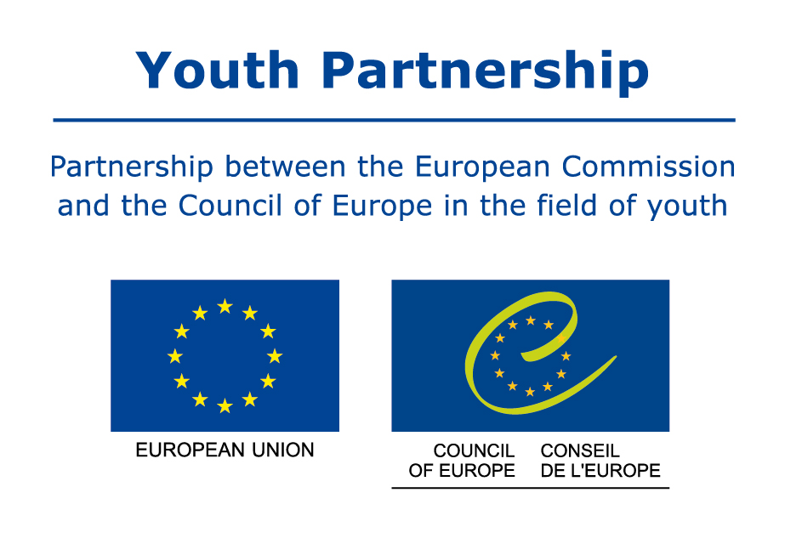
“BE (COME) A YOUTH POLICY CHANGE MAKER!”
 | MONDAY, DECEMBER 16TH | TUESDAY, DECEMBER 17TH | WEDNESDAY, DECEMBER 18TH
9.00 – 11.00 | - Welcoming and Opening  - Intro to context, frame, programme, team and venue  - Getting in touch: Me and youth policy  - Getting started: What experiences do I have? | Discovering different concepts of youth policy ( rights, needs & wellbeing) | Creative thinking session: youth policy from the perspective of various youth policy stakeholders
11.00 – 11.30 | Coffee Break
 | Diving in: What is my vision regarding youth policy? | Comparing different concepts and understanding what could be improved | Creating a list of key actions to be implemented + sharing with all other groups
13.00 – 15.00 | Lunch
 | Overview of European youth policy frameworks  Creation of timeline of milestones | Introduction of main principals of  youth policy | Information on opportunities and framework programmes (E +)  Which cooperation activities could we imagine?
16.30 – 17.00 | Coffee Break
17.00 – 18.30 | Spotlight on examples of youth policy frameworks across Europe  (successes and failures) | What are the most important concepts and principles for my context? | Sharing, finding partners in the room  Next steps, follow-up, support options
20.00 | Dinner
 |  | Tour in Malta | Farewell event
MALTA, 16-18 DECEMBER, 2013

