
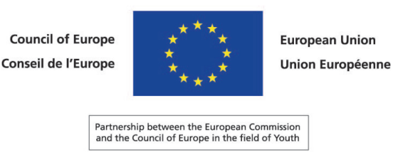

YOUTH POLICY DEVELOPMENT
in Eastern Europe and caucasus

Konstancin-Jeziorna, Poland
6th-9th July 2009

Seminar report
by Jonathan Evans
- Introduction:

  - Context of Workshop:

Youth policy development has been one of the main concerns of the Council of Europe for the best part of the past four decades. Informed by this considerable experience, the partnership between the European Commission and the Council of Europe in the field of Youth has made youth policy the focus of its regional co-operation. The SALTO Eastern Europe and Caucasus Resource Centre is currently working within the context of the European Commission’s decision to support the Youth in Action Programme as part of its policy of co-operating more closely with Neighbouring Partner Countries from Eastern Europe and the Caucasus Region (Armenia, Azerbaijan, Belarus, Georgia, Moldova, the Russian Federation and Ukraine).

The first Seminar on the development of youth policy within the region took place in the European Centre in Budapest in June 2008. It was organised by the EU-CoE youth partnership with the support of the SALTO EECA Resource Centre. The event brought together 17 participants, most of whom came from countries within the region. A majority came from non-governmental organisations, but youth researchers and government representatives with responsibilities in the field of youth affairs were also present. The aim of the Seminar was to promote youth policy development as a way of addressing the needs of young people in Eastern Europe and Caucasus. A full report of the Seminar is available on-line (http://www.youth-partnership.net/youth-partnership/documents/EKCYP/Youth_Policy/docs/YP_strategies/Youth_Policy_Development_in_Eastern_Europe_and_Caucasus.pdf). Following the success of this first Seminar it was proposed that a second Seminar should be held in 2009.

  - Seminar Objectives:

The stated aims of the 2009 Seminar were expressed in the following terms:

- Sharing the understanding of the current situation, needs and aspirations of young people in the respective countries.
- Discussing the role of youth policy, youth work and youth research in better identifying and addressing those needs and aspirations.
- Considering possible future initiatives to this end, on local, national and international levels.

The aim was to secure representation from the three key constituencies: those working in government with statutory responsibilities for youth affairs, researchers and practitioners (including non-governmental youth organisation members and youth leaders).

  - Participation in the Seminar:

The Seminar was duly hosted by the SALTO EECA Resource Centre in Konstancin-Jeziorna, Poland. A total of 22 participants attended and contributed to the Seminar, including representatives from the EU-CoE youth partnership, the SALTO EECA Resource Centre, the European Youth Forum and the European Commission’s Youth in Action Programme. Additionally, civil servants from the Polish government, a youth researcher from Warsaw University and the rapporteur were present. Although all countries from the region were represented, it was regrettably not possible to secure the attendance of the above-mentioned three key constituencies from every member-state. The NGO sector formed the largest proportion of those attending from the region. Nevertheless, it is important to emphasise the point that the governmental sector and the research community were represented at the event. A full list of participants is reproduced in Appendix 2.

  - Programme:

The Seminar Programme can be found in Appendix 3.

- Introductory Session (6th July 2009)

Ms Marta Mędlińska (Youth Research and Policy Officer from the partnership between the European Commission and the Council of Europe in the field of Youth) welcomed participants to the second seminar devoted to youth policy development in the region. She outlined briefly the nature of the partnership as well as highlighted the importance of the supportive role played by SALTO EECA RC in the region. Ms Mędlińska moved on to welcome the guests from the host country, Mr Jaroslaw Jankowski (Head of the Department of Communications, Polish Ministry of Education) and Mr Tomasz Bratek (Director of the Polish National Agency of the Youth in Action Programme).

Mr Jankowski welcomed participants to his country. He spoke of some of the political sensitivities within the region and commented that it was therefore a good time to meet. This opportunity allowed people from the different countries to review successes, share ideas and contemplate common problems. In Poland work on the development of youth policy was undertaken some nine years ago. It was reported that the Polish National Youth Council is in the process of being created. From a Polish perspective it was certainly an opportune moment to review policy within the country. The discussion taking place at this Seminar was therefore of interest to those concerned with youth policy in Poland. Whilst Mr Jankowski was unable to attend the whole Seminar, it was announced that one of his colleagues would be joining participants for the rest of the programme.

Mr Tomasz Bratek also welcomed participants to Poland. He outlined some of the youth initiatives that were taking place within the framework of the European Community’s Youth in Action Programme, but commented that there was scope for more applications being made from countries within the region. It was acknowledged that there was maybe a need to streamline administrative procedures for youth organisations applying for funds. The Youth in Action Programme is, he explained, the main financial tool currently used to facilitate international youth co-operation between the European Union and the region of Eastern Europe and Caucasus. Funding was available for projects in such areas of activity as voluntary service, youth exchange, non-formal education, and training and networking. Mr Bratek hoped that the Seminar would not only be an important networking opportunity within which to review youth policies, but also be used to consider ways in which collaborative practical action could be taken to enhance the lives of young people in the region.

Ms Mędlińska thanked both contributors from Poland and commented that the importance of focusing on young people’s needs had been well highlighted in their presentations.

Mr Hanjo Schild (Coordinator of the partnership between the European Commission and the Council of Europe in the field of Youth) welcomed participants, including those who had attended last year. He touched upon visa issues and how it was important to facilitate improved mobility for young people across Europe, but especially for those from certain countries in the region. Mr Schild then went on to underline the core activities of the EU-CoE youth partnership in the field, including the development of high quality youth work training, knowledge production through research, and youth policy development. He also located the regional development strategy in Eastern Europe and Caucasus within the wider context of initiatives in other regions such as Euro-Med and South-Eastern Europe. As far as this Seminar was concerned, one of the key aims should be to explore ways in which equal opportunities could be created for all citizens in Europe; and this included young people in the region. Finally, participants should be aware of two key documents that are likely to shape youth policy discussions now and in the coming years: Agenda 2020 (Council of Europe, 2008) and Youth: Investing and Empowering (Commission of the European Communities, 2009).

Mr Andriy Pavlovych (Coordinator of SALTO Eastern Europe and Caucasus Resource Centre, Poland) welcomed participants and reminded those present of the work undertaken by SALTO in the region. Mr Pavlovych invited participants and colleagues in their networks to help the Centre in its work of facilitating closer co-operation between the European Union and Eastern Europe and Caucasus. The importance of involving stakeholders was emphasised. Whilst young people were the beneficiaries of the available programmes it was also essential that they became actively involved in shaping initiatives in the region; indeed, they needed to assume the role of equal partners in the whole process.

Attention was drawn to the fact that Poland would be assuming the Presidency of the Council of Europe after Sweden. There were plans to make youth policy a particular focus during this period. Therefore, any input on how youth policy could be taken forward both generally and at a regional level would be most welcome.

There followed a round of introductions in which participants were asked to identify themselves and say a few words in relation to their expectations of the event. This part of the session was enhanced by an exercise in which people wrote down their expectations on pieces of adhesive paper; these were then placed on the wall of the Seminar Room. The comments can be divided broadly into two main themes. The first highlights the virtues of simply bringing people together. It evidences the intrinsic value of sharing information, comparing experiences, developing analyses, exchanging ideas and simply networking. The second theme, arising from the activities of the first theme, involves translating ideas into concrete action. All of the participants, it has to be said, understood the close relationship between the two themes and this is reflected in the comments. Set out below are the expectations shared by participants. It is difficult to group the comments neatly into thematic categories, but they probably fall into three main categories:

- The Importance of Information Sharing and Reflection;
- The Importance of Translating Information and Reflection into Action; and
- The Inextricable Relationship between Reflection and Action.

A fuller account of the expectations cited by participants can be found in Appendix 8. It includes a set of direct quotations from those in attendance.

Ms Mędlińska concluded the session by outlining the programme of the Seminar. She also explained the rationale behind the request for the completion of the youth policy templates (see Appendix 4) by governmental representatives, researchers and practitioners (typically involved in Non-Governmental Organisations). The aim had been to have this information available from each country in the region in advance of the Seminar. Unfortunately, this information had not been supplied by all countries beforehand (see Appendix 5 for completed Youth Policy Templates completed prior to the Seminar). Nevertheless, there would be an opportunity to use the template during the course of the Seminar Programme in order to help develop a clearer picture of the profiles in the respective countries within the region. In the case of some countries this information was already available via the European Knowledge Centre for Youth Policy (http://www.youth-partnership.net). In other cases, though, the information could not be accessed from this source. In the circumstances participants were therefore asked to present brief but systematic accounts of the state of national youth policy in their respective countries. This included an explanation of the national context, a basic social profile of the country’s youth and a description of the key agencies, services and actors in the field. The presentations followed the format of the Youth Policy Templates (see Appendix 4). It was, of course, accepted that in some cases it would not be possible for participants to provide comprehensive information. Nevertheless, identifying gaps in knowledge is an intrinsically useful exercise.

- Session: Young People in the Region – Keynote Address by Expert and Discussion (7th July 2009)

Ms Klaudia Wojciechowska from the Polish Ministry of Education joined the Seminar and explained that Poland, in anticipation of taking over the Presidency of the Council of Europe, would be working closely with Sweden on youth policy in the coming period. She was, therefore, very keen to learn from the Seminar discussions. Ms Wojciechowska also emphasised the point that the region of Eastern Europe and Caucasus was extremely important as far as future youth policy development was concerned.

This session was devoted to an academic presentation by Dr Joanna Konieczna-Salamatin of the Institute of Sociology at Warsaw University. The title of the paper delivered was Youth in Eastern Europe and Caucasus: A general overview of Values and Attitudes. The full text of the paper is available in Appendix 6.

Dr Konieczna-Salamatin’s analysis was based on data available in two waves of the World Values Surveys (1995/1997 and 2005/2007) and one wave of the European Values Survey (1999/2000). Influenced by the work of Professor Ronald Inglehart at the University of Michigan at Ann Arbor, the paper explored the relevance of his theoretical distinction between ‘materialist’ and ‘post-materialist’ values to describe generational attitudinal shifts in the respective countries of the region. Dr Konieczna-Salamatin presented the survey results in respect of young people’s attitudes across a range of issues, including gender equality, sexual orientation, the market economy and political values. The presentation provided a very helpful stimulus for discussion.

Participants duly asked questions and offered interpretations of the data as they related to their own countries. Additionally, the following points were made. The methodological limitations of the survey data, readily acknowledged during the course of the presentation, included the problem of representing the rich diversity of youth within each country in terms of age, ethnicity, sexual orientation and geography. The validity of Ingelhart’s terminology (‘materialist’ and ‘post-materialist’) was questioned, as was the apparent assumption he makes that economic and physical insecurity necessarily overrides the desire for ‘self-expression’ and the pursuit of ‘spiritual’ fulfilment. Does it always follow that a hungry person does not think about philosophy? The example of a country like India would appear to contradict this assumption. Notwithstanding these points concerning Inglehart’s theoretical orientation, the data presented and the incisive contribution of Dr Konieczna-Salamatin were greatly appreciated by all participants.

- Session: Youth Policy and the Needs of Young People: what, why and how? The respective roles of youth policy, research and practice (7th July 2009)

Ms Marta Mędlińska and Mr Hanjo Schild gave a presentation entitled Youth Policy Essentials, which referenced the following sources: Finn Yrjar Denstad’s forthcoming book, Youth Policy Manual: How to Develop a National Youth Strategy; and the United Nations’ World Youth Report (2005) with particular reference to ‘Ten Steps to National Youth Policy Formulation’. The essential features of presentation can be summarised in the following terms.

A national youth policy represents a government’s commitment to its young people. This is expressed not only in policy documents, but also through a government’s actions and practices. This policy will comprise core elements that are universal and will apply to all young people as well as those that are, to varying degrees, targeted towards particular groups (for example, those who are vulnerable or troublesome). A national youth policy is, however, larger than the sum total of its various constituent parts. Individual policies should be bound together by a coherent youth strategy document that clarifies the philosophy, values and general direction of travel. Some aspects of youth policy are likely to be underpinned by statute. Nevertheless, legislation is not a pre-requisite for a good youth policy.

Effective national youth polices should possess a number of different features. According to Denstad (in press) it should involve a clearly defined government authority on youth; well defined target groups; a concrete and transparent strategy; a research, or evidence-based, policy; a view that young people are a resource rather than a problem; a commitment to promoting youth participation; a cross-sectoral and integrated approach to youth policy; inter-ministerial co-operation; a separate budget; established links between local and national levels; and alignment with European and other international practices.

The United Nations have identified ten steps that need to be followed when constructing a national youth policy (http://www.un.org/esa/socdev/unyin/nationalpolicy.htm): the participation of those for whom the policy is being designed; a rigorous needs analysis; the identification of vulnerable groups’ needs; assessing the existing resources available; establishing a budget dedicated to the implementation of the youth policy; drawing appropriate lessons from previous experience; developing a clear, overarching vision; creating, and being prepared to revise, an institutional structure that will support and service the policy; engaging in partnerships for action; and monitoring and evaluating performance in relation to clearly stated aims and objectives.

- Small Group Sessions on the Situation of Young People and the State of Youth Policy in the Countries of the Region (7th July 2009)

Participants split into four small groups in order to share informally the social condition of young people and the state of youth policy in their respective countries. The aim was not only to compare and contrast experiences, but also to identify common themes. In these discussions, reference was made to some of the concepts mentioned in the earlier presentation. The main themes that emerged from each of the groups are summarised below.

Group 1 (included representatives from Armenia, Russia and Poland)

- At the outset it was acknowledged that these are difficult times, economically and politically, for young people. It was therefore not the most conducive environment within which to develop youth policy.
- Long-term national youth strategies sometimes ran counter to the prevailing and/or short-term political agenda. Consequently, there could sometimes be a lack of continuity in terms of developing coherent national youth strategies. Some questioned whether a long-term national youth strategy was either practicable or necessary. It was felt that it was maybe more important to pass legislation in the field of youth; the argument being that statutes are binding, whereas strategies are ‘soft’ and can be sidelined.
- Cross-sectoral issues were discussed. It was pointed out that in many cases personnel moved back and forth across different sectors. This included those who moved between the governmental sector and NGOs.
- The relationship between national and local youth policy was discussed. In one country the national youth policy was under the direct control of the Prime Minister. The point was made that local youth policies were probably more important because this was the point of service delivery. Moreover, it was at the local level that young people’s needs could be best identified and met. In short, it is at local level that the effectiveness and impact of services can be felt.
- It was reported that the National Youth Council in Poland should now be more effective.
- The challenge of bringing national youth policies into alignment with European and international standards and practices was discussed.
- One problem identified was the way in which responsibility for youth issues could be tossed like a ball between one Department and another. The result in some cases is that youth affairs are not dealt with effectively because there is a lack of clarity with regard to where ultimate responsibility resides. In effect, youth issues can fall between the policy crevices that frequently exist between Departments.
- The question was asked whether European youth policies were really needed when representatives from the different countries didn’t meet regularly. Given this lack of contact with other European countries, how meaningful was the concept of ‘European’ policies in the region?

Group 2 (included representatives from Armenia, Azerbaijan, Georgia and Moldova)

- Whilst there were very different realities in all of the countries represented, there were also similarities and commonalities present.
- One of the issues identified was a lack of transparency in some cases (in terms of decision-making, for example).
- In Armenia the concept of youth is well developed and a law on youth affairs is currently under construction.
- In Azerbaijan there is a relevant statute and a new youth programme. Other initiatives are currently at the developmental stage.
- In Georgia there is no relevant legislation in place, but the process to put a law on the statute books has commenced.
- In Moldova there is a law on NGOs.

Group 3 (included representatives from Moldova, Belarus and Azerbaijan)

- One of the challenges identified was to depoliticise youth policy in the sense of widening its ownership beyond the apparatus of the state. Currently, there are examples of youth policy in the region being too heavily freighted with ideological baggage. Militarism and rather prescriptive forms of ‘patriotic education’ risk stifling attempts to create a culture of active citizenship amongst young people.
- There are cases where the relationship between government and civil society is in need of considerable improvement. For example, NGOs need to be given meaningful opportunities to engage constructively with government in the development and implementation of youth policy. In essence, there needs to be an active partnership between government and civil society.

Group 4 (included representatives from Russia and Armenia)

- The youth strategies of Russia and Armenia were compared and contrasted.
- The importance of good quality research was recognised.
- The importance of promoting good quality youth work practice was underlined.
- The relationship between politics and youth work practice was debated.
- Cross-sectoral issues were discussed. Co-operation between different Ministries and with the NGO sector were considered essential pre-requisites for the effective delivery of youth policy.
- Budgetary issues were considered in terms of the needs at national, federal (in the case of Russia) and local levels.
- The relevance of European youth policy to the national contexts of Russia and Armenia was discussed. The view was taken that both Russia and Armenia are key youth policy actors at the European level.
- Russia has a new set of state structures responsible for the formulation and delivery of youth policy. The National Youth Council has an important role to play in the policy formation process, especially in terms of drawing attention to problems being experienced by young people.
- There was a view expressed that many young people are not really interested in state youth policy. Guidance from the EU-CoE youth partnership on this issue would be welcomed.
- It is important to evaluate the effectiveness and impact of youth-related laws. How are they implemented and to what extent do they work?

- Session: The Situation of Young People and the State of Youth Policy – Country Presentations

Participants delivered presentations of the situation in their respective countries. Summarised below are the salient features of these contributions. A more detailed profile of Armenia (see below) can be found in Appendices 5 and 7.

  - Armenia

    - Historical Overview:

- The post of Deputy Minister on Youth Affairs and the Youth Policy Department has been in existence since 1995.
- The National Youth Council of Armenia (NYCA) was established in 1997.
- The State Youth Policy Concept Paper was published in 1998.
- There has been a representative of Armenia in the European Steering Committee on Youth (CDEJ) of the Directorate of Youth and Sport of the Council of Europe since 1998.
- The Youth Affairs Council was established by the Prime Minister in 2000.
- The Pan-Armenian International Youth Centre Foundation was established in 2001.
- The ‘Centre for Organising Youth Activities’ state Not-for-Profit organisation was established in 2002.
- The Youth Award of the President of Armenia was introduced in 2004.
- The National Youth Council of Armenia (NYCA) became a full member of the European Youth Forum in 2004.
- The National Youth Report of Armenia was published in 2006.
- The ‘Republic of Armenia 2008-2012 State Youth Policy Strategy Paper’ was published in 2008.

    - Statistics:

- There are 850,000 young people aged 16-30 years.
- The gender profile is 60% female, 40% male.
- More detailed information on the social situation, health, education, participation and other aspects of young people’s lives can be found in the National Youth Report (http://www.youthpolicy.am). Other statistics can be found on http://www.armstat.am

    - Actors and Structures

In Armenian society the youth sector is represented by the following bodies and organisations: youth NGOs; Student Councils and Student Scientific Societies; the youth wings of political parties; the National Youth Council of Armenia; and thematic networks of youth NGOs.

The state sector, meanwhile, is represented by the following structures: the Ministry of Sport and Youth Affairs and the Youth Policy Department; the ‘Centre for Organising Youth Activities’ State Not-for-Profit organisation and 10 regional youth centres; the ‘Pan-Armenian International Youth Centre’ Foundation and International Youth Centre; and the Standing Commission for Education, Science, Culture, Youth Affairs and Sports in the Parliament of the Republic of Armenia.

Additionally, there are two fora within which co-management principles can be applied in practice: the Prime Minister’s Youth Affairs Council; and the Expert Council for the Allocation of State Grants from the budget of the Republic of Armenia to youth NGOs.

A diagrammatic representation of the relationship between these different bodies is available in Appendix 7.

    - Legislation and other Guidance:

- The adoption of the State Youth Policy Concept Paper (1998)
- The ‘Republic of Armenia 2008-2012 State Youth Policy Strategy Paper’ (2008)
- The Law on Youth Affairs (under construction)
- Statutes of the Council on Youth Affairs by the Prime Minister of the Republic of Armenia (awaiting approval)

    - National Youth Programmes

- The National Programme for Youth Housing (under construction)
- The National Programme for Car Loans (under construction).
- The Action Plan on Non-Formal Education (under construction)

    - State Budget on Youth Affairs: 1997-2009:

The budget dedicated to youth affairs is summarised below:

Thousand Euros

1997: 59.5
1998: 116.0
1999: 168.7
2000: 215.3
2001: 215.3
2002: 303.7
2003: 390.9
2004: 363.1
2005: 553.6
2006: 627.0
2007: 654.8
2008: 666.7
2009: 819.4

    - International Co-operation

A significant contribution to international co-operation is made by the Armenian Diaspora. In particular the following organisations play a significant role: the Pan-Armenian International Youth Centre Foundation; the International Youth Centre in Tsakhkadzor; and the All-Armenian International Forum 2003-2008.

International co-operation is also effected in the following terms: the Youth Section in the Action Plan EU-Armenia in the framework of the ENPI; implementation activities in the framework of Agenda 2020 of the Council of Europe; actions in the youth sector under the Eastern Partnership of the European Commission (Commission of the European Communities, 2008); co-operation with international organisations operating in Armenia; bilateral co-operation with the governments of European and other countries; intercultural festivals 2006-2008; and annual training courses of PAYICF on ‘Intercultural Learning and International Youth Work’ and ‘European Youth Policy, Programmes and Structures’ (2005-present).

  - Azerbaijan

    - Context

A state youth policy was drafted in 2002. This remains the framework within which current youth policy operates. Youth issues are a major concern of government. The intellectual and educational development of the country’s young people is a high priority.

    - Statistics

Youth is defined as all those young people aged between 14 and 29 years. This age group represents approximately 30% of the country.

    - Actors and Structures:

There exists a Ministry responsible for Youth and Sport, a functioning National Youth Council (established in 1994, it joined the European Youth Forum in 2000) and approximately 170 youth NGOs. It should be mentioned, however, that only 70 members of these NGOs are represented on the National Youth Council. The youth NGO sector is increasingly important as young people’s organisations become more independent of government, thus strengthening the fabric of civil society.

    - Legislation:

A law on youth policy regulates the key aspects of policy and services in this area.

    - National Youth Programmes

The key initiatives in this area are the Azerbaijan Youth State Programme for Young Families (2005-2009) and the State Youth Student Programme which funds some 5,000 young people to study abroad (mainly to the UK, France and Germany). A new Youth State Programme will be ready in a few months (2010-2015).

    - Budgets

The current annual youth budget is approximately 3 million euros, with around 150,000 euros going directly to youth NGOs.

    - International Dimension:

Azerbaijan youth policy is enhanced by engagement with the following organisations and structures: the Council of Europe (Directorate of Youth and Sport), the European Youth Foundation, the OSCE, the European Youth Forum and Diaspora-AAYSA. More recently, young people from Azerbaijan have been involved in the Islamic Conference Youth Forum.

  - Belarus

    - Context:

The youth policy context of Belarus tends to be overshadowed by the ideological orientation of the government. This is reflected in the way in which public funding is distributed, with ‘patriotic education’ attracting more resources than alternative activities offered by youth NGOs.

    - Statistics:

The definition of youth has changed from 16-31 years of age to 14-35 years. There are 235 youth NGOs in existence, but only 14 on the official ‘register’.

    - Actors and Structures:

The Department of Youth Affairs is located in the Ministry of Education. The Department of Youth Affairs has local Departments in every region. As mentioned previously, there are 235 youth NGOs operating in the country, but only those on the official register (currently 14) receive government support.

    - Legislation:

Decree N200 provides the framework for youth policy in the country.

    - National Youth Programmes:

Reference was made to the National Programme for the Youth of Belarus 2006-2010. The focus of the programme is in such policy areas as crime prevention, supporting young families and those with addiction problems. It is difficult to evaluate the impact of these and other programmes because it is alleged that the practice of ‘double counting’ takes place.

    - Budget:

The annual budget is currently 100,000 euros.

    - International Dimension:

Most international co-operation takes place within the framework of the CIS.

  - Georgia:

    - Context:

- The State Department of Youth and Sport was established in 1994.
- The National Council of Youth Organisations of Georgia was founded in 1995.
- The President’s Decree of 12th March 2001 on the National Concept of Youth Support 2001-2005 could not be implemented and was duly repealed in 2003.
- There is no official state youth policy in existence at the present time.

    - Statistics:

- The present law defines young people as those aged between 18 and 26 years. According to this definition there are 707 100 young people in Georgia, which represents 16.12% of the total population. However, it should be mentioned that if the definition of youth was widened to include those aged between 15 and 30 years, the figure rises to 1 057 200, which is 24.12% of the population.
- Gender Profile: Female 51%; Male 49%.

    - Actors and Structures:

- The Ministry of Culture, Monument Protection and Sport is responsible for developing state policy culture, cultural heritage, sport and youth. It also co-ordinates the implementation of policy on the regional level. Various cultural, sporting and youth activities are organised as well as relevant policy research in these areas. The strategy is aimed at promoting successful international cooperation in the fields of culture, sport and youth.
- The State Department of Youth and Sport (which operates under the auspices of the Ministry of Culture, Monument Protection and Sport) (a) coordinates the realisation of state policy in the youth field; (b) prepares proposals for future development of legislation in relation to children and young people; (c) aims to create conditions conducive to youth participation and social inclusion; (d) co-ordinates co-operation between youth and children’s organisations; (e) supports young people at the level of the state by protecting their rights and interests; and (f) promotes the establishment and proper implementation of state youth programmes.
- The State Youth and Children’s Centre (which is the responsibility of the State Department of Youth and Sport) supports the development of Youth NGOs and organises annual small grant competitions.
- The Youth and Sport Committee at the Parliament of Georgia scrutinises government youth policy on Youth and Sport whilst the Scientific Consultative Council actively works on the development of youth-related laws.
- The National Council of Youth Organisations of Georgia (NCYOG) is the main non-governmental, non-profit umbrella organisation working on behalf of young people and represents over 48 youth and children’s organisations. The NCYOG:
- Represents and advocates on behalf of the interests of youth organisations in co-operation with relevant authorities and institutions in Georgian society;
- Supports the development of youth work and makes policy proposals on youth issues to both state and international institutions;
- Actively promotes democracy, pluralism, human rights and the wider values on which every democratic society is based;
- Supports Euro-Atlantic integration (which is a major plank of Georgia’s present foreign policy); and
- Promotes voluntarism, diversity and solidarity amongst youth organisations.

    - Legislation:

The existing statute is the Law for State Support of Children and Youth NGOs. At the present time, however, draft versions of a new law are being developed independently by the NCYOG and government.

    - National Youth Programmes:

The main programmes available are state-sponsored Patriotic Youth Camps. Meanwhile some projects run by youth NGOs receive funding from different local and international foundations.

    - Budget:

The 2009 budget dedicated to state actors in the field of youth can be summarised in the following terms:

- The State Department of Youth and Sport: 2,000,000 GEL to be spent exclusively on patriotic camps for young people.
- The Youth and Children’s Foundation: 1000,000 GEL available for the NGO sector
- The State Youth and Children’s Centre: 500,000 GEL from the state budget and 1,219, 350 GEL coming from the World Bank for the development of regional youth centres.

It should also be mentioned that that YNGO sector has the possibility of applying to various local and international foundations.

    - International Dimension:

There is a low level of international participation by government, although the NGO sector tries to liaise and integrate with international networks and structures. Representatives of NCYOG have been elected to different bodies within the European Youth Forum. This year (2009) representation on the Council of Europe’s Advisory Council on Youth has also been achieved.

  - Moldova

    - Context:

Cross-sectoral youth policy exists in the country, but it is still very much in the process of being developed. It is, however, heavily influenced by the politics of government. Having said that, there is still scope for constructive co-operation with government.

The delivery of the Council of Europe’s International Review report is imminent. It will be interesting to see what effect the report has on the future development of youth policy in the country.

Education is a major concern. This domain of policy needs to be addressed as a matter of high priority.

Youth policy has received a great deal of attention recently because 2008 was the national Year of Youth and 2009 is the Year of Youth in the CIS countries.

    - Statistics:

Youth was defined as being 16-28 years of age. It should be noted that there is a proposal from youth organisations to extend the age within the draft law to 35 years.

The available statistical data reflects many of the trends and issues that affect young people in other countries; the challenges of moving from formal education into the labour market being just one area. It should also be noted that of the population whose origins are from outside the country, 40% are young.

    - Actors and Structures:

It was reported that a diverse range of youth NGOs operated within the country. There is, however, a lack of transparency in the decision-making processes in the whole area of youth. There is therefore scope for the development of co-management practices between the governmental and youth NGO sectors. There is a commitment to establishing a Youth Commission; hopefully after the parliamentary elections.

    - Legislation:

Legislation exists, but the perception is that it doesn’t work very effectively. There is a need to harmonise the different strands of legislation in different policy areas.

There are laws currently being drafted in volunteering and public finances. There is also discussion on whether to adopt the ‘law of 2%’.

    - National Youth Programmes:

There are a variety of programmes across different sectors, but the main one is the Youth Strategy for 2009-2013. However, concern was expressed that the programmes tend to be heavily politicised. Moreover, because of funding decisions, many of the programmes are disrupted or lack a sense of continuity. They are also not evaluated in terms of proper standards of quality control. Moreover, they are often not based on young people’s needs (although an HIV programme targeting young people was mentioned). The problem is that the programmes do not appear to be related sufficiently clearly to a coherent national youth policy.

    - State Budgets:

In addition to the dedicated state budget, funds are also received from donors. The overall impression is that financial support for the youth sector is inadequate (an estimated 0.1 euro per person per year), but it is difficult to calculate the precise level of funding because of the way in which accounts are maintained; for example, expenditure on youth policy is subsumed within the wider Ministry of Education budget. It was also pointed out that no direct financial support was given to NGOs.

    - International Dimension:

Areas in which there has been engagement at international level include: the EU Action Plan (Eastern Partnership); the Youth in Action programme; the CIS, Baltic and Balkans States Co-operation; donors and international diplomatic missions; international conventions; and the YFJ.

  - Russia

It should be noted that detailed analysis of the position in Russia is available via the country’s profile on the European Knowledge Centre (http://youth-partnership.net). Nevertheless, the summary below highlights the salient points.

    - Context:

There is a move away from the short-term perspectives that have characterised Russian youth policy in the past. Youth policy is finally being integrated into the longer-term strategic objectives of government.

    - Statistics:

There is a population of 142.2 million people in the Russian Federation. Young people (defined as being between the ages of 14 and 30 years) represent 26.6 % of the total population.

    - Actors and Structures:

The ministry with overall responsibility for youth is the Ministry of Sport, Tourism and Youth Policy. Within the Ministry is the Department of Youth Policy and Public Relations. Other national bodies directly involved in youth policy are the Federal Agency on Youth Policy; and the Parliamentary Commission of Youth Issues; the State Duma on Youth. Below this Federal level are regional public authorities with competences in the youth field.

In the non-governmental sector, of course, the National Youth Council of Russia plays a vital role in the field of youth affairs. There also exists a range of youth NGOs throughout the Federation.

    - Legislation:

There are 7 key laws on Youth and NGOs (for further details see pages 12-13 in the above mentioned ‘Country Sheet on Youth Policy in Russia’ at the European Knowledge Centre).

    - National Youth Programmes:

Attention was drawn in particular to the two programmes below:

- Action Plan for 2009 Year of Youth; and
- The Strategy of the State Youth Policy in Russian Federation 2006-2016

    - Budget:

Public expenditure on youth in 2009 amounts to 2, 804 586 thousand rubles.

    - International Dimension:

The CIS is obviously an important framework for international co-operation as are the following:

- Council of Europe (including European Youth Foundation; and the Framework Programme for Co-operation between the Russian Federation and the Council of Europe)
- European Commission (including the Youth in Action Programme; the European Volunteer Service; and Youth in the World)
- European Youth Forum

  - Ukraine

    - Context:

Youth Policy is overseen by the Ministry of Youth, Families and Sport. Most young people appear to be unaware of Ukrainian youth policy. Apparently, only 6.7% of young people feel the direct influence of youth policy on their lives.

    - Statistics:

It was suggested that the available statistics may not be entirely reliable. Nevertheless, it would seem that young people (defined as being aged between 14 and 35 years) represent 33% of the total population. There is also a discernible trend of migration from rural areas to large towns and cities. 70% of young people in Ukraine live in urban areas.

    - Actors and Structures:

The hierarchy of youth policy is represented by the above-mentioned Ministry at the top and local Departments of Youth at municipal level. Youth NGOs and youth fora engage with these national and local government structures. Some useful youth research has been undertaken, but there are still significant gaps in knowledge.

    - Legislation:

20 statutes have references to the youth field. This is a very high rate when considered alongside other groups in society. The view was expressed, though, that youth politics exists in Ukraine rather than a coherent youth policy. There is, nevertheless, awareness of Agenda 2020.

    - National Youth Programmes:

- National Programme for Support of Young People for 2009-2010
- Grant Programme for National youth NGOs administered by the Ministry.

    - Budget:

Not known.

    - International Dimension:

There are agreements on bi-lateral co-operation in the youth field with 41 countries in the world. There is also close and growing interest in the programmes available through the Council of Europe and European Commission (including, of course, the partnership between the Council of Europe and the European Commission in the field of youth). The use of co-management principles within the Council of Europe are helpful to developing awareness of how youth policy should be developed in partnership with young people. ERASMUS was mentioned as being significant. The European Union’s Neighbourhood policy and the Eastern Partnership are potentially extremely important to Ukraine

Conflict Resolution:

Given some of the international tensions in the region, Mr Hanjo Schild made a general comment about the availability of training kits on conflict resolution. He explored the idea of whether there was some scope for holding training events in this area. The idea was well received by participants.

- Session: European Youth Policies: the perspectives of the Council of Europe and the European Union (8th July 2009)

Mr Hanjo Schild outlined recent developments in youth policy within the Council of Europe and the European Union. In a wide-ranging address the following salient points emerged.

Key European documents were summarised. These included:

- the White Paper on Youth (2001); and
- the European Youth Pact (2004)

A new strategy, Youth: Investing and Empowering (Commission of the European Communities, 2009) has emerged out of a massive review and evaluation of past policy and practice. It has included a thorough review of relevant documents and evaluations as well as consultation with partners, including the European Youth Forum. The resolution being put before the Council of Ministers at the end of 2009 will outline a strategy stretching between 2010 and 2018. The Action Plan in the first three years of that period will be crucial.

Although one sometimes wonders who actually reads these important documents, the significance of these recent developments in European youth policy should not be underestimated. It is important to understand that the strategy represented by Youth: Investing and Empowering is partly the product of a wider political context at a crucial point in history. The main priorities of the European Union are currently:

- the economic crisis;
- climate change;
- and the social agenda.

There are also seven key challenges which have been identified by the European Commission:

- globalisation;
- demographic trends;
- diversity;
- migration;
- various social problems;
- democratic participation; and
- climate change.

The new strategy requires the direction of resources to the priority policy areas if young people are to reach their potential. It means creating opportunities in:

- education;
- employment; and
- creativity and entrepreneurship.

This also requires the improvement of access to:

- modes of participation; and
- health and sport.

Social solidarity, meanwhile, should be fostered through:

- volunteering;
- social inclusion measures; and
- ways of helping young people engage with the wider world.

The tools that will assist the effective implementation of this piece of work are:

- reporting (including country reports and joint reports);
- evidence-based policy-making;
- peer learning between countries (at both higher and lower, ‘cluster’ levels);
- structured dialogue with young people at all levels;
- mobility programmes and funds (such as Youth in Action);
- and co-operation with other institutions and organisations (including the Council of Europe).

As far as the Council of Europe is concerned, the crucial document that needs to be considered is the Agenda 2020 declaration (Council of Europe, 2008); the Final Declaration of 8th Council of Europe Conference of Ministers responsible for Youth’ in Kyiv – 10-11 October 2008, ‘The Future of the Council of Europe’s Youth Policy: 2020’. This document sets out priorities and a medium-term strategy for the Council of Europe in the field of Youth Policy. There are three key areas in which the Council should work:

- human rights and democracy;
- living together in diverse societies; and
- ensuring the social inclusion of young people.

In order to work successfully in these three areas it is vital that:

- young people play an essential role in promoting the Council’s core values;
- the youth dimension should be mainstreamed throughout the Council of Europe;
- there should be increased co-ordination between child and youth policy as well as practical action; and
- a prominent role is given to co-management in the structures of the Council of Europe and in collaborative ventures with the European Union.

The youth policy of the Council of Europe has been confirmed in the three core areas mentioned previously. The proposed methods and instruments for optimising work in the field are:

- intergovernmental and international co-operation , including with the European Union;
- services to member states, including Advisory Missions and International Policy Reviews;
- other partnerships and forms of co-operation with stakeholders, youth organisations and the research community;
- co-management; and
- inter-cultural dialogue and non-formal learning.

Revisiting the Council of Europe’s core areas of activity, a number of supporting points were made. Firstly, In relation to human rights and democracy:

- young people’s commitment to, and enjoyment of, human rights and human dignity should be encouraged;
- the active participation in democratic structures and processes of everyday life should be promoted;
- gender equality policies should be implemented and campaigns against gender-based violence conducted;
- education and action on the environment, and support for sustainable development; and
- the facilitation of access to information and counselling services.

Secondly, in relation to living together in diverse societies, the following comments are made:

- the promotion of global solidarity, cultural diversity and inter-cultural dialogue, and the fight against all forms of discrimination;
- support for conflict resolution/transformation projects;
- support for youth work with refugees, asylum seekers and displaced persons; and
- the development of sub-regional youth co-operation in Europe and beyond.

Thirdly, on the subject of social inclusion and young people, there is a need to:

- integrate excluded young people;
- ensure access to education, training, working life and cultural, sporting and creative activities, in particular through the use of non-formal learning;
- ensure smooth transitions from education to the labour market;
- support autonomy, wellbeing and access to decent living conditions; and
- encourage intergenerational dialogue and solidarity.

Finally, a preliminary comparison was made of the practical actions and measures taken by the Council of Europe and the European Union in order to make progress on the agenda items already mentioned. Whilst there is considerable overlap in terms of priorities and objectives, there are also areas of specific expertise that distinguish the roles played by the respective institutions.

Both institutions set similar priorities in the following areas: active participation; access to culture, sport and creative activities; access to social inclusion, education, training and employment; autonomy, well-being and decent living conditions; sustainable development; and (sub-regional) co-operation in Europe and the world.

The Council of Europe, however, offers specific expertise in the following areas:

- human rights and dignity;
- global solidarity;
- conflict resolution/transformation;
- work with refugees, asylum seekers and displaced persons;
- gender equality; and
- the Youth Worker portfolio.

Meanwhile, the European Union provides:

- with Europass/Youthpass a tangible instrument for recognition of non-formal learning;
- concrete strategies in the areas of lifelong learning, employment and social inclusion;
- free movement of labour across the European Union;
- entrepreneurship programmes; and
- volunteering programmes (EVS).

These represent solid achievements that enhance the lives of many young people.

- Session: Existing International Youth Policy Co-operation Initiatives in the EECA Region (8th July 2009)

This session, which aimed to identify the diverse sources of support for collaborative work, was facilitated by Mr Andriy Pavlovych. The results of this exercise are summarised below:

- European Community Programmes (including the Youth in Action Programme).
- European Youth Foundation.
- Twinning (local councils, municipalities and public authorities in civil society; the Cultural Cities Programme).
- World Bank (Youth Voices; Youth Empowerment; Human Rights; Health; Environment);
- Campaigns (All Different All Equal, including follow-up activities with the assistance of government partners in such countries as Russia and Azerbaijan);
- East-East Programme (SOROS Foundation)
- Open Society Foundation
- Black Sea Trust (German Marshall Foundation). The priorities are participation, co-operation and economic reform. They have a funding stream for the region.
- European Neighbourhood Policy (European Union) and particularly the Eastern European Partnership (funding streams include Democracy and Contacts between People).
- Reference was also made to a joint initiative by the Swedish government and Swedish Youth Council that involved all National Youth Councils in the region.
- Cross-Border Co-operation between neighbouring countries.

Governmental sources include:

- Russia World Foundation (for countries where the Russian language is spoken).
- GUAM (Georgia, Azerbaijan, Ukraine and Moldova)
- CIS Youth Co-operation
- Club of Ministers for Youth Affairs.
- Central European Initiative (approximately 11 countries are involved; annual meetings on youth are held).
- European Union Ministers of Foreign Affairs.
- DFID (UK government). All governments have aid Departments and/or agencies.
- Public Diplomacy Division of NATO (Ministries of Foreign Affairs).
- UNICEF (no open calls, but will work through governments; some NGOs can be co-opted; on occasions travel costs are covered).
- UNDP
- UN Democracy Fund
- Global Conflict Prevention Tools

- Sessions Identifying the Areas of Future Action and Co-operation (8th-9th July 2009)

There followed a series of small-group discussions and ‘open space’ sessions (where people could join more than one group to discuss ideas and initiatives), interspersed with short ‘report back’ plenary fora. Participants were asked to engage in a five-step process:

      - reflect on their national needs;
      - develop ideas, initiatives and proposals for co-operation and collaboration with colleagues from other countries;
      - present and discuss their ideas to other interested participants (using the ‘open space methodology’);
      - visit other participants’ presentations and discuss with them the possibility of developing the concept/s (again using the ‘open space’ methodology); and
      - present the outcome of the whole process to a plenary session.

Firstly, summarised below, are reflections on the national needs of the respective countries represented at the Seminar:

Belarus:

- Greater involvement by civil society (young people, NGOs, etc.) in the decision-making process.
- Better dialogue with the public authorities.

Moldova:

- Training and information.
- Instruments and tools for research and policy implementation.
- Research on youth.

Armenia:

- Transparency in youth policy processes, mechanisms and monitoring.
- Improving co-management
- Structural co-operation in the framework of the ENP and EaP.
- Improved relations with neighbouring countries.
- Development of international co-operation and inter-cultural learning.

Azerbaijan:

- Active partnership with youth organisations in the implementation of state youth programmes (funding of grant projects; direct co-operation with European Commission programmes).
- Enlarge integration of youth organisations in Western structures (to increase international access for youth from all parts of the country).
- Active involvement of youth organisations in European Union co-operation.
- The development of lobbying instruments within and outside the country (to develop the capacity to share international experience in conflict resolution and peace building).

Ukraine:

- To foster dialogue between different youth policy stakeholders.

Russia:

- To address the needs of young people. Given the unemployment crisis, income will decline and young people’s quality of life and general lifestyle will be affected adversely.
- There is need to generate work and training placements within the region.
- It is against the above background that young people’s mobility is improved in order for them to move to new employment, work experience and/or education/training. It is proposed that the obstacles to mobility need to be removed (for example, by securing better visa agreements with other countries).

Georgia:

- Support co-operation between Georgia and representatives from the conflict area and the wider region.
- The need for participation at national level by different youth organisations.
- A law on youth affairs is required.
- A state youth policy needs to be developed.

Proposals for Ideas for International Co-operation are listed below:

- A training seminar on conflict transformation through inter-cultural dialogue and learning. (Armenia)
- A study visit to Armenia; the focus being National Youth Policy. It would include familiarisation with (a) the realities of youth work in the country; (b) youth policy systems; and (c) an exploration of possible international co-operation. (Armenia)
- Training tools and instruments for policy implementation. (Moldova).
- Regular youth policy monitoring reports. (Moldova)
- The Year of Youth. Georgia needs international projects to support this initiative. (Georgia)
- Holding an Eastern Partnership Forum meeting in Baku in order to discuss issues of common interesting in the region. (Azerbaijan)
- Youth Employment and Youth Policy. (Russia)
- The Eastern Partnership and its youth dimension in 2011 (the year of the Polish Presidency). Which topics would be relevant? Which problems should be brought to the table? How should Poland contribute? (Poland)
- A workshop of all EECA countries and EU member-states that would address the question of how to mainstream youth policy development issues in the Eastern Partnership. (Anonymous)

The results of the ‘open space’ exercise, in which participants developed concrete proposals for collaborative work, are summarised below. It will be noted that some proposals were merged and others dropped. Nevertheless, some of the proposals were endorsed and developed quite significantly.

Initiative (Poland): The Eastern Partnership
What topics should be discussed? Who should be there? How should the Polish presidency contribute?

Participants: Poland, Russia, Armenia, Georgia, SALTO EECA and Moldova

What was discussed and decided?

To use the Presidency and the Eastern Partnership as a forum for discussion on:

- Common co-operation (EU and EECA). How, what for, in favour of which structures, and how much will it cost?
- Existing structures and alliances: Balkans, Baltic, etc. What are the experiences? Which structures and practices are effective?
- How can EECA and Eastern Partnership ‘profit’ from this co-operation?
- Possible solutions and opportunities to increase the modalities of EECA (in favour of EVS, developing improved mobility and visa arrangements, etc).
- Promoting volunteering (EVS)
- Identifying future challenges.

Initiative (Moldova): The Development of Tools for the Implementation of Youth Policy.

Participants: Moldova, Poland, Belarus, Ukraine

What was discussed and decided?

It was decided to ‘unfold’ a pilot project. There would be a study session for public authorities at the local level on non-formal approaches to youth policy using the best instruments to realise a good youth policy and to put in place effective mechanisms for their management. The study session should be for all countries with support from the CoE. In terms of participants at the training event there would be a 50/50 split between NGOs and the government sector. A collaborative, partnership approach to project development would be encouraged at the training event.

There are many tools that can be used to implement youth policy work. There is a need for an exchange of practices between different public authorities and, of course, between the governmental sector and NGOs.

Initiative (Moldova): Regional Youth Policy Monitoring Reports

Participant/s: Moldova

What was discussed and decided?

The idea of the initiative was to have regular updates on the available research and reports. This could then be developed into a common report for the whole region.

Unfortunately, the discussion did not take place.

Initiative (Armenia): Training Seminar in Conflict Transformation through intercultural learning

Participants: Moldova, Azerbaijan, SALTO EECA RC, Russia, Georgia

What was discussed and decided?

- Possible place: Lviv (if YiA Project) or Strasbourg (if Study Session of EYF)
- Possible Participants: MEDA conflicting countries, SEE countries, and EECA conflicting countries, Programme countries of YiA which have had or are currently experiencing problems or conflicts.
- Aims: to empower youth workers and civil servants in working with the topic of conflict transformation through dialogue between cultures and intercultural learning. SALTO EECA RC will provide possible support and may participate.

Initiative (Armenia): Study Visit on National Youth Policy in Armenia (possibly using the same format for second study visit to Azerbaijan).

Participants: Moldova, Azerbaijan, SALTO EECA RC (it will possibly provide support and perhaps participate), Russia and Georgia.

What was discussed and decided?

- Participants: 7 programme countries and 7 EECA countries. Possible applicant: Turkey.

Aims and Programme:

- Visits to YNGOs: Organisational Fair and round of visits to YNGO offices.
- Visits to NYP key actors in state sector:
  - Parliament: appropriate Commissions on Youth and European integration
  - Ministry of Youth Affairs: Minister, Deputy Minister and Youth Policy Department;
  - National Youth Council of Armenia;
  - Possibly the President and Prime Minister

- Exploring youth work realities in Armenia and participating countries
- Exploring youth policy schemes and mechanisms in Armenia and participating countries.
- Exploring the possibility of international co-operation in the NYP sphere and beyond.

- Concluding Session and Evaluation (9th July 2009)

An evaluative discussion of the whole Seminar was facilitated by Ms. Marta Medlinska. A particular concern was the under-representation of policy makers. Different formats for future events were discussed, but no conclusive view was reached. It was, however, suggested that policy makers might be persuaded to attend if their presence was required for only one and a half days. The comment was also made that the presence of politically high-level keynote speakers might influence attendance. This is, however, clearly a matter for further reflection and consultation.

The following points emerged from the rest of the discussion:

- There was a general feeling that, compared with last year, this Seminar was more grounded and had produced some specific and concrete proposals.
- The possibility of bringing together EECA and SEE at a joint Seminar was mooted. It was generally considered to be a good idea.
- Thought needs to be given to monitoring activity between Seminars. It is important that good ideas are followed through with concerted action.
- It is important that country profiles of EECA members are uploaded to the European Knowledge Centre.
- There needs to be stronger involvement of the region in European level activities.
- There should be enhanced dialogue between research, policy and practice.
- There should be more exchange of information and good practice.
- Civil society needs to be cultivated in the region.
- There needs to be more political leadership in the field of youth.
- It is vitally important that we gain more knowledge about youth in the region.

Mr Andriy Pavlovych echoed many of the comments already made. He made it clear that SALTO EECA would continue to lobby vigorously for the region and do its utmost to facilitate collaborative work. He reiterated the point that applications for the Youth in Action programme needed to be increased. Finally, the point was made that the partnership between the Council of Europe and the European Commission in the field of youth really is working very successfully. It demonstrates how it is possible for institutions to work together effectively.

Mr Tomasz Szopa led the formal evaluation. Participants were asked to write answers to four questions:

      - What were the best elements in the Seminar for you?
      - What were the challenges for you at this Seminar?
      - What could have worked better here?
      - What would you like to change in the concept of such events in the future?

Participants were duly thanked for their valuable contributions to the Seminar.

Although the results of the formal evaluation are reported fully in Appendix 9, it should be recorded here that the comments and general mood in this final session were overwhelmingly positive. There was, moreover, a sense of optimism that tangible outcomes would emerge from the Seminar

References

Commission of the European Communities (2008) Communication from the Commission to the European Parliament and the Council: Eastern Partnership, (Sec (2008) 2974), Brussels, 3.12.2008, COM (2008) 823 final, Brussels: Commission of the European Communities

Commission of the European Communities (2009) Communication From the Commission to the Council, The European Parliament, The European Economic and Social Committee and the Committee of the Regions; An EU Strategy for Youth – Investing and Empowering, A renewed open method of coordination to address youth challenges and opportunities, Brussels: Commission of the European Communities

Council of Europe (2008) 8th Council of Europe Conference of Ministers responsible for Youth - Kyiv, Ukraine, 10-11 October 2008 – “The future of the Council of Europe youth policy: AGENDA 2020” Declaration, Strasbourg: Council of Europe, MJN-8 (2008) 4

Denstad, FY (in press) Youth Policy Manual: How to Develop a National Youth Strategy, Strasbourg: Council of Europe Publishing

United Nations (2005) Youth at the United Nations: World Youth Report (http://www.un.org/youth) and ‘Ten Steps to National Youth Policy Formulation’ (http://www.un.org/esa/socdev/unyin/nationalpolicy.htm)

Appendix 1: Acronyms

Appendix 2: List of Seminar Participants

Appendix 3: Seminar concept paper

Appendix 4: Youth Policy Template

Appendix 5: Youth Policy Templates completed prior to the Seminar

5.1: Armenia

Appendix 6: Paper by Joanna Konieczna-Salamatin – Youth in Eastern Europe and Caucasus: A General Overview of Values and Attitudes

Appendix 7: PowerPoint Presentation of Youth Policy in Armenia

Appendix 8: Seminar Participants’ Expectations:

Appendix 9: Evaluation of Seminar

Appendix 1: Acronyms

EaP = Eastern Partnership

EECA = Eastern Europe and Caucasus

ENP = European Neighbourhood Policy

SALTO = Support, Advanced Learning and Training Opportunities

SEE = South East Europe

Appendix 2: List of Seminar Participants

ARMENIA

Mr. Arsen Karamyan
Ministry of Sport and Youth Issues of Republic of Armenia
Abovyan St. 9
Yerevan
Email: arsenkaramyan@yahoo.com

Mr. Atom Mkhitaryan (excused)
Sebastia St. 12 - 33
0065 Yerevan
Tel: +374 91 20 07 98
Email: mkhitaryan@yahoo.com

Mr. Areg Tadevosyan
Nor-Aresh 32 str. house 12
0075 Yerevan
Tel: +374 93 05 05 60
Email: areg.tadevosyan@gmail.com

AZERBAIJAN

Mr. Vugar AHMADOV
Sharifzade Street 73
apartment 35
BAKU
Tel: +994 50 343 53 02
Email: vugarahmadov@yahoo.com

Mr. Ramil Khalilov
Olimpia str. 4
072 BAKU
Tel: +994 504 46 54 78
Email: ramilxalilov@yahoo.com

BELARUS

Mr. Yaroslav Oleinik
V. Khoruzhey 5 "b"/20
220005 Minsk
Tel: +375 296 849 746
Email: yaros74@gmail.com

GEORGIA

Mr. Vakhtang Asanidze
Vazha-pshavela ave. 5 dist. 1 block, falat 10
0186 Tbilisi
Tel: +995 55 91 09 26
Email: vakho82@yahoo.com

Mr. Valeri Jokhadze
“Children and Youth National Center”
under the Ministry of Culture Monuments Protection and Sport of Georgia
76b Vazha Pshavela ave
0186 Tbilisi
Tel/Fax: +995 32 30 22 53
Mobile: +995 77 410 441
Email: g.jokhadze@cync.ge

MOLDOVA

Mr. Valeriu Ciorba
5 Nucarilor str. Colonita MD
2082 Chisinau
Tel: +373 795 57 559
Email: vciorba@gmail.com

Ms. Vera Turcanu
27 Renasterii str. apt 36
Chisinau
Tel: +373 794 02 172
Email: veraturcanu@gmail.com

RussiaN FEDERATION

Ms. Ruzanna Ivanyan
Moskovsky pr. 106. 34
196084 Saint-Petersburg
Tel: +79 217 526 039
Email: rouzanna@youthcentre.ru

Mr. Denis BARINOV
National Youth Council of Russia
Maroseyka 3/13
101990 Moscow
Org. Tel: +7 495 624 00 16
Fax: +7 495 624 00 18
Email: dbarinov@youthrussia.ru

UKRAINE

Ms. Evgeniia Petrivska (excused)
14 Desyatynna str. of.204
01023 Kyiv
Tel: +38.067.231.42.84
Email: spectrhead@mail.ru
Evgeniia.petrivska@undp.org.ua

Mr. Andriy Donets
Prospect Illica 79/31
83003 Donetsk
Tel: +38050 255 46 35
Email : andryushkad@yahoo.com

EUROPEAN YOUTH FORUM

Mr. Hamlet OHANYAN
Abovyan 19, apt 8
0001 Yerevan
Armenia
Tel: + 374 91 19 76 86
Email: hamlet.ohanyan@gmail.com

UNITED KINGDOM (rapporteur)

Mr. Jonathan Evans
Centre for Criminology,
Faculty of Humanities and Social Sciences,
University of Glamorgan,
Pontypridd CF37 1DL
Wales
Tel: +44 0 1443 482241
Email: jwevans@glam.ac.uk

SALTO Eastern Europe and Caucasus Resource Centre (Poland)

Mr. Andriy Pavlovych
Mr. Tomasz Szopa
Eastern Europe and Caucasus Co-operation
Polska Narodowa Agencja Programu "Młodzież w działaniu"
ul. Mokotowska 43
00-551 Warsaw
Tel: +48 22 621 62 67
+48 22 46 31 460
Fax: +48 22 621 62 67
Email: eeca@salto-youth.net

Partnership between the European Commission and the Council of Europe
in the field of Youth
c/o Council of Europe
Directorate of Youth and Sport
67075 Strasbourg Cedex
FRANCE
Fax : +33.388.41 27 77
Mr. Hanjo Schild
AGORA - B6.22.V
Tel: +33.390.21 56 31
Email: joachim.schild@coe.int

Ms. Marta Mędlińska
AGORA, B6.26.V
Tel.: +33 390 21 4916
Email: marta.medlinska@coe.int

Appendix 3: Seminar concept paper

YOUTH POLICY DEVELOPMENT
in Eastern Europe and Caucasus

Konstancin Jeziorna, Poland, 6th-9th July 2009

Context

Youth policy development has been one of the main focuses of the Council of Europe for over three decades now. Based on this rich experience the Youth Partnership between the Council of Europe and the European Commission has focused its regional cooperation in this issue.

The SALTO Eastern Europe and Caucasus Resource Centre continues working on the basis of European Commission’s decision to support the cooperation within the Youth in Action Programme with Neighbouring Partner Countries from Eastern Europe and Caucasus Region.
In June 2008 the workshop on the development of youth policy in Eastern Europe and the Caucasus took place at the European Youth Centre in Budapest, organised by the Youth Partnership joint programme of the Council of Europe and the European Commission with the support of the SALTO Eastern Europe and Caucasus Resource Centre (see the report at: http://youth-partnership.coe.int/youth-partnership/documents/EKCYP/Youth_Policy/docs/YP_development/Youth_Policy_Development_in_Eastern_Europe_and_Caucasus.pdf). The event brought together 17 participants, most of whom came from the countries in the region. A majority came from the non-governmental youth sector, but the were also government representatives and researchers in the youth field attending the seminar.

The objective of the workshop was to promote youth policy development through the advancement of a regional dialogue in the countries of Eastern Europe and the Caucasus and the sharing of information. Participants’ presentations on the situation of youth policy in their respective countries was followed by identifying concrete challenges and major needs for further progress in youth policy development. Regional cooperation was considered a valuable tool to overcome barriers to improve the situation of young people in these countries.

The seminar resulted in a number of concrete proposals for follow-up and concrete future action in order to improve the development of youth policy in the region of Eastern Europe and the Caucasus. One of the proposals was considering organising a follow-up event, a seminar gathering representatives of youth policy, research and youth work/youth organisations from every country in the Region. Such a forum would provide an opportunity for involving new relevant youth policy stakeholders and furthering the discussions on youth policy development in the Region.

This is against this background that the Youth Partnership and SALTO EECA are jointly organising the second seminar focused on youth policy development in Eastern Europe and Caucasus.

Objectives

- Increasing the knowledge of the current situation, needs and aspirations of young people in the respective countries.
- Sharing, comparing and learning from developments in the fields of youth policy, youth work and youth research in the individual countries and on the European level.
- Enhancing constructive dialogue between governmental representatives, youth worker practitioners and youth researchers.
- Supporting and empowering existing youth structures.

Participants

Representatives of the youth policy, youth research and youth work practitioners/representatives of youth organisations from Armenia, Azerbaijan, Belarus, Georgia, Moldova, the Russian Federation and Ukraine as well as experts from other European countries are invited to the event.

Organisational aspects

Board and lodging during the seminar will be provided by the organisers. Visa and travel costs will be reimbursed. Concrete logistical information will be sent to those who will have confirmed their participation by May 10th by registering on-line at:
http://www.youth-partnership.net/youth-partnership/seminars/seminar_7.html

Programme

The programme is meant to provide time and space for sharing – exchange of experience within the youth sector from the perspectives of policy making, research, youth work practice; reflecting on past and current state of affairs, needs and aspirations, visions and plans for the future. It is also meant to be flexible and accommodating the flow of discussions, which should be supported by a small size of the group and working character of the meeting.

The thematic working groups will focus on priority issues identified by the participating experts, considered as key and the most beneficial to joint cooperation in social, political, economic and cultural spheres of youth policy.

 | 6th July | 7th July | 8th July | 9th July
9.00 | A  R  R  I  V  A  L  S  Welcome words  Introductory session | Keynote address on the situation of young people in the Region. Discussion | Identifying the areas of future action and cooperation | Presentations of the next steps  Identifying synergies and support measures needed
11.00 | A  R  R  I  V  A  L  S  Welcome words  Introductory session | Coffee break | Coffee break | Coffee break
11.30 | A  R  R  I  V  A  L  S  Welcome words  Introductory session | Presentations of the state of youth policy in the Region, new developments | Working groups according to the identified areas of future action and cooperation | Concluding session  Closing
13.00 | A  R  R  I  V  A  L  S  Welcome words  Introductory session | lunch | lunch | lunch
14.30 | A  R  R  I  V  A  L  S  Welcome words  Introductory session | Presentations of the state of youth policy in the Region, new developments - continued | Working groups continued | D  E  P  A  R  T  U  R  E  S
16.00 | A  R  R  I  V  A  L  S  Welcome words  Introductory session | Coffee break | Coffee break | D  E  P  A  R  T  U  R  E  S
16.30 | A  R  R  I  V  A  L  S  Welcome words  Introductory session | Drawing conclusions from the presentations  Discussing the roles of various stakeholders in shaping the youth sector | Preparing concrete next steps | D  E  P  A  R  T  U  R  E  S
19.00 | Dinner | Dinner | 20.00 Dinner out

Further information may be obtained from the Partnership secretariat – please, do not hesitate to contact Ms. Marta Medlinska (Marta.Medlinska@coe.int) as well as SALTO EECA RC – please, contact Mr. Andrij Pavlovych (Andrij.Pavlovych@frse.org.pl).
Appendix 4: Youth Policy Template

YOUTH POLICY TEMPLATE

For inspiration please see:
http://youth-partnership.coe.int/youth-partnership/ekcyp/Country_2007

- Context of national youth policy
- Statistics on young people
- Main needs of young people which should be addressed by the youth policy
- Actors and Structures
  - Public authorities
    - National public authorities
    - Regional public authorities with competencies in the youth field
    - Local public authorities with competencies in the youth field
  - Youth welfare services (comprising public and/or non public actors)
  - Non-public actors/structures & youth services with competencies in the youth field
    - Youth councils
    - Youth NGOs
  - Other structures
- Legislation
- National Programmes on youth
- Budget / Public expenditure allocated to youth
- International Dimension of youth policy (e.g. Council of Europe, European Union, international donors organisations etc.)
Appendix 5: Youth Policy Templates completed prior to the Seminar

5.1: Armenia

YOUTH POLICY TEMPLATE
Research perspective

- Context of national youth policy
The Republic of Armenia has implemented a structured state policy on youth since 1995.
The state body responsible for developing and implementing a state youth policy in Armenia is the Ministry of Culture and Youth Affairs. In 1995, a Department for Youth Affairs (presently—a Youth Policy Department) was created, which is a major achievement for the youth segment of civil society.
As a result of structural reform in the Ministry in 1998, the “youth affairs” domain was separated; in 2002, its name was changed to “youth policy.”
Under Decree 798 dated December 14, 1998, the Republic of Armenia Government adopted the first document concerning the state youth policy—the “State Youth Policy Concept Paper.”
Under Decree 734 dated November 7, 2000, the Republic of Armenia Prime Minister created a Youth Affairs Council under the Prime Minister.
Structural change has been accompanied with the creation of new state structures responsible for the implementation of the state youth policy.
Under Decree 520 dated June 11, 2001, the Republic of Armenia Government created the “Pan-Armenian International Youth Center” Foundation, the goal of which is to develop and implement joint projects to foster the collaboration between young people in Armenia, the Armenian Diaspora, and foreign states. A building and some space were allocated to the Center in the Town of Tsaghkadzor: now, the Center can aspire to gain the status of a regional youth center of the Council of Europe.
Under Decree 418 dated April 17, 2002, the Republic of Armenia Government created the “Center for Organizing Youth Activities” State Non-for-Profit Organization, the goal of which is to organize and implement projects and activities to foster the state youth policy.
In 2004, according to an instruction of the Prime Minister, the office of a Youth Affairs Specialist was introduced in each Marzpetaran (regional government office) of Armenia.
An important building block of the state youth policy is the “Republic of Armenia 2008-2012 State Youth Policy Strategy Paper” developed by the Sport and Youth Affairs Ministry in early 2008 with support of YNGOs and other state structures.
The aim of the State Youth Policy Strategy is to improve young people’s living conditions, to organize their leisure, and to enhance their participation in social and political processes. It encompasses social, political, and cultural issues affecting the youth. This Strategy treats the youth as a direct beneficiary and important stakeholder of events.
The Republic of Armenia Culture and Youth Affairs Ministry strats to implement an unprecedented project since 2006: creating “Marz Youth Centers,” as representative offices of the “Center for Organizing Youth Activities” State Non-for-Profit Organization, in collaboration with local self-government bodies and Marz non-governmental and international organizations, which focus on delivering the state youth policy to the Marz youth, more effectively engaging the latter in programs, and raising the Marz youth’s awareness of the youth policy. The Marz Youth Centers are managed by Governing Councils comprising representatives of the aforementioned organizations. The Youth Centers operate as resource centers where young people have access to a variety of necessary services (legal and health counseling, computer services, a library, and a reading hall), including training courses to improve their knowledge, employment advice, and pastime opportunities. Since 2006 10 Regional Youth Centers are created in all of the regions of Armenia.
Since 2004, a periodical covering issues related to the state youth policy and the youth has been published, which also addresses youth events and the problems faced by the youth, and enables young people and youth organizations to present their activities and views publicly. The periodical is aimed at raising public awareness of the youth policy.
The Armenian state youth policy website has been operational since 2005 in both English and Armenian. From the beginning of 2006, a biweekly youth television show „Generation of Independance” is broadcasted, presenting the needs, problems, and expectations of the youth, public youth-related events that are not covered by mainstream news, raising the awareness of the more passive part of the youth about civil society activities, and promoting the process of integration with the international community.
In the implementation of the state youth policy in Armenia, there is a focus on collaboration with different structures, including other countries’ agencies responsible for the implementation of state youth policy and international organizations.
Governmental and non-governmental organizations are engaged in the implementation of the state youth policy in Armenia, which increases the effectiveness of the policy. The cooperation with the National Youth Council of Armenia (NYCA) is especially worth mentioning. In 1998, an office equipped with the necessary technical facilities was allocated to the NYCA.
Since 2001, the Prime Minister issues decrees by which annual awards are bestowed upon young people and the presidents of youth organizations that have made a remarkable contribution to public, political, cultural, and other non-governmental work in the country during the year.
According to Decree NH-219-N of the President of Armenia dated December 24, 2004, the “Youth Award of the President of Armenia” was introduced, which is bestowed upon gifted young authors in fine arts, cinema, music, and literature.
Since 1998, a great deal of attention has been paid to international cooperation and partnership building in the youth sector. Collaboration with international organizations is becoming rather active. There is a particular focus on cooperation with the Directorate of Youth and Sport of the Council of Europe (international conferences, as well as a number of training courses and workshops on youth issues). In 1998, a representative of Armenia was included in the European Steering Committee on Youth (CDEJ) of the Directorate of Youth and Sport of the Council of Europe. A key achievement in 2004 was the inclusion of Armenia’s representative in the Council of Europe Bureau of the European Steering Committee on Youth.
Another achievement of youth civil society was that, in November 2004, the National Youth Council of Armenia (NYCA) became a full-fledged member of the European Youth Forum (since 2000, the NYCA had been a candidate for membership in the European Youth Forum).
Developing international cooperation in the youth sector is important not only in the frameworks of different international organizations, but also through the establishment of bilateral contacts, concluding agreements, and implementing joint projects.

- Statistics on young people
According to the 2005 Armenia Statistical Yearbook published by the National Statistical Service of the Republic of Armenia, the 16-30 year-old population of Armenia was 821,600 (25.6% of the total population).
Information on the Social Situation, Health, Education, Participation and other aspects can be found in the National Youth Report
  - National Youth Report on www.youthpolicy.am
  - Other statistics on www.armstat.am

- Main needs of young people which should be addressed by the youth policy
Social support and welfare
Youth unemployment
Youth participation
Training and Life-long learning
Leisure time activities
International mobility and cooperation
Youth in remote regions
Conflict transformation and cooperation with neighbouring countries

- Actors and Structures providing knowledge on young people (providing knowledge on young people)
Youth Research is not very well developed in Armenia. The biggest achievement was development of National Youth Report on 2006, which has given a possibility to redraft the Strategy of Youth Policy in Armenia. In 2007-2008 the Strategy was revised and a new Startegy Paper was developed for the years 2008-2012 based on the results of the research.
It is foreseen that the data accumulated in National Youth Report will be regularely updated, and for this each year there are financial means allocated in state budget.
  - Public authorities
    - National public authorities
    - Regional public authorities with competencies in the youth field
    - Local public authorities with competencies in the youth field
  - Youth welfare services (comprising public and/or non public actors)
  - Non-public actors/structures & youth services with competencies in the youth field
    - Youth councils
    - Youth NGOs
  - Other structures
- Legislation
- National Programmes on youth
- Budget / Public expenditure allocated to youth
- International Dimension of youth policy (e.g. Council of Europe, European Union, international donors organisations etc.)

YOUTH POLICY TEMPLATE
Policy perspective

- Context of national youth policy
The national youth policy in Armenia has been started to be developed since 1998, when the post of Deputy Minister on Youth Affairs and Department of Youth Policy were created and the Conception on National Youth Policy was adopted by the government of RA. Since that time a lot of development has taken place, a number of infrastructures and mechanisms has been set up. The state budget on youth affairs has reached 413 million AMD and most of the finances are spent via YNGOs developing and implementing programs.
- Statistics on young people
Young people aged 16-30 are 850.000. The gender balance is 60 female % to 40 % male.
- Main needs of young people which should be addressed by the youth policy
The main areas of functioning of National Youth Policy identified during the research project on 2005-2006 (as a result of which National Youth Report was produced) are.
- Youth participation
- Employment
- Social support systems
- Education (formal and non-formal)
- Youth research and information
- International/European cooperation
- Actors and Structures
  - Public authorities
    - National public authorities
The coordinating public authority on national level is the Ministry of Sport and youth Affairs. In the framework of the Ministry a Department of Youth Policy is created with two Commissions (Programs Commission and Cooperation Commission). The co-management principle is provided through the Council on Youth Affairs by the Prime-Minister of Armenia, composed of equal numbers of YNGO and state actors.
    - Regional public authorities with competencies in the youth field
There is a Network of 10 Regional Resource Centres of the Ministry of Sport and Youth Affairs in all the regions of Armenia. This Resource Centres serve as information and education platforms operating on regional level. The Centres are governed by governing Boards composed of the representatives of the governing bodies of the Center, representatives of International Donor Community operating in appropriate region and representatives of regional local YNGOs.
    - Local public authorities with competencies in the youth field
The Regional Youth Centres create local networks of partners (alongside with donors that operate in regions) and work on development of Youth Policy implementation strategy on local level.
  - Youth welfare services (comprising public and/or non public actors)
At the moment there are no youth-specific welfare systems. The systems that operate are those of Employment Centers of the Government of RA, appropriate social support systems under the Poverty Reduction Strategic Program and other general welfare systems. The Government of RA now develops a strategic program providing housing and cars loans to young people and young families, which will be launched in 2010.
  - Non-public actors/structures & youth services with competencies in the youth field
    - Youth councils
    - Youth NGOs
  - Other structures
The Government of RA with support of Diaspora Donors has created a Foundation for complementary support to young people’s and YNGOs international cooperation and work with youth from Diaspora. In this framework Pan-Armenian Youth International Center Foundation has been created in 2000 with its International Youth Center in Tsakhkadzor. The Board of Trustees of the Foundation is governed by the Prime-Minister of Armenia and is composed of YNGO representatives and Governmental structures.
- Legislation
There is no low on Youth Affairs in Armenia, but it is under development by some parliamentary fractions.
- National Programmes on youth
Based on the National Youth Report on 2006 s Strategy of Youth Policy was developed by the Ministry of Sport and youth Affairs and YNGO partners for the years 2008-2012.
- Budget / Public expenditure allocated to youth
The State Budget of Armenia allocates a separate line of funding for state youth policy projects; every year, the amount of funding for specific projects grows.
Considering the importance of developing the state youth policy in Armenia, annual budgetary allocations for youth projects during 1997-2006 are presented below:
Drams million (1AMD=358USD on July 10, 2009)
Year | 1997 | 1998 | 1999 | 2000 | 2001 | 2002
Amount of funding | 30 | 58.45 | 85 | 108.5 | 108.5 | 153.075

Drams million (1AMD=358USD on July 10, 2009)
Year | 2003 | 2004 | 2005 | 2006 | 2007 | 2008 | 2009
Amount of funding | 197 | 183 | 279 | 316 | 330 | 330 | 413

In view of the fact that young people also benefit from a part of state budget funding for education, health care, social security, physical education, sports, and other sectors, it can be said that there is in fact a larger amount of state funding for the youth.
- International Dimension of youth policy (e.g. Council of Europe, European Union, international donors organisations etc.)
The Government of RA cooperates with Council of Europe since 2002. Three training courses are organized in this framework in Armenia. Armenian Government also work with CoE through CDEJ and YNGO sector through YFJ.
On 2006 the Ministry with cooperation of YNGO sector partners has developed the youth part of European Neighbourhood Partnership Initiative’s Armenia-EU Action Plan.
Last half a year together with the Ministry of Foreign Affairs some activities are in the development in the framework of Eastern Partnership initiative.
Appendix 6: Paper by Joanna Konieczna-Salamatin – Youth in Eastern Europe and Caucasus: A General Overview of Values and Attitudes

Joanna Konieczna-Sałamatin
Institute of Sociology
Warsaw University
Joanna.Konieczna@is.uw.edu.pl

Youth in Eastern Europe and the Caucasus:
An overview of their values and attitudes
(Draft, not for publication)

The current text is an attempt to assemble relevant data that are available and provide an analysis of the values shared by societies in the seven countries of Eastern Europe and Caucasus: Belarus, Moldova, Russia, Ukraine, Armenia, Azerbaijan and Georgia.
Comparative data for analysis have been provided by the large-scale international project, the World Values Survey. It is within this framework that all seven countries have been studied; some of them more than once.

Data sources used in the analysis

The following data sets have been used in the analysis:
- the World Values Surveys (WVS) – two waves: 1995/1997 and 2005/2007; and
- the European Values Survey (EVS) – one wave: 1999/2000 (study in Moldova finished in 2002)

The list of datasets for countries under study is set out below:

Country | Year of data collection | Data Source
Belarus | 1999 | EVS
Moldova | 2000/2002; 2005 | EVS, WVS
Russia | 1999; 2005 | EVS, WVS
Ukraine | 2000; 2005 | EVS, WVS
Armenia | 1997 | WVS
Azerbaijan | 1997 | WVS
Georgia | 1996; 2005 | WVS

Theoretical background

Before presenting the results of the surveys concerning the values shared in the seven East-European countries, there is a need to describe briefly the theoretical background of the project and the terms used within this presentation.

The idea of studying values is rooted in the works of Prof. Ronald Inglehart from the University of Michigan, Ann Arbor. In his often cited work, ‘The silent Revolution’ he suggested that ‘a transformation may be taking place in the political culture of advanced industrial societies. This transformation seems to be altering the basic value priorities of given generations as a result of changing conditions influencing their basic socialization’ (Inglehart 1971: 991). Inglehart found large differences between values shared by older and younger generations in six West-European societies and proposed a division between ‘materialist’ values – emphasizing physical and economic security – and ‘post-materialist’ ones that emphasise autonomy and self-expression. Referring to the work of psychologists, who presented the evidence that people’s basic values change relatively little during the life-course (Rokeach 1968), Inglehart argued that the observed differences reflect intergenerational value changes and not a tendency for people to get more materialistic as they get older. This expected replacement of the dominant system of values caused by generation replacement was described as a ‘culture shift’ which takes place as a result of growing economic prosperity.

The first large-scale international project devoted to studying values in a way that allows cross-country comparison was started in 1978 by Prof. Jan Kerhofs from the Catholic University of Leuven and Prof. Ruud de Moor, Rector of the University of Tilburg. The project name is the European Values Survey and its history is directly connected with the processes of European integration. The main question posed by the project’s initiators was whether the members of the European Community share common values. Do, for example, Christian values retain their importance in the lives and culture of Europeans? The EVS questionnaire covered a wide range of issues – from values related to family life and work to religion, morality, the economy and politics. The first survey was conducted in 1980. It was then complemented by the World Values Survey, based on a similar questionnaire and directed by Prof. Inglehart. Its first wave started in 1990. One of the results of the World Values Study was the Cultural Map presented by Inglehart and Welzel (Figure 1).

Figure 1.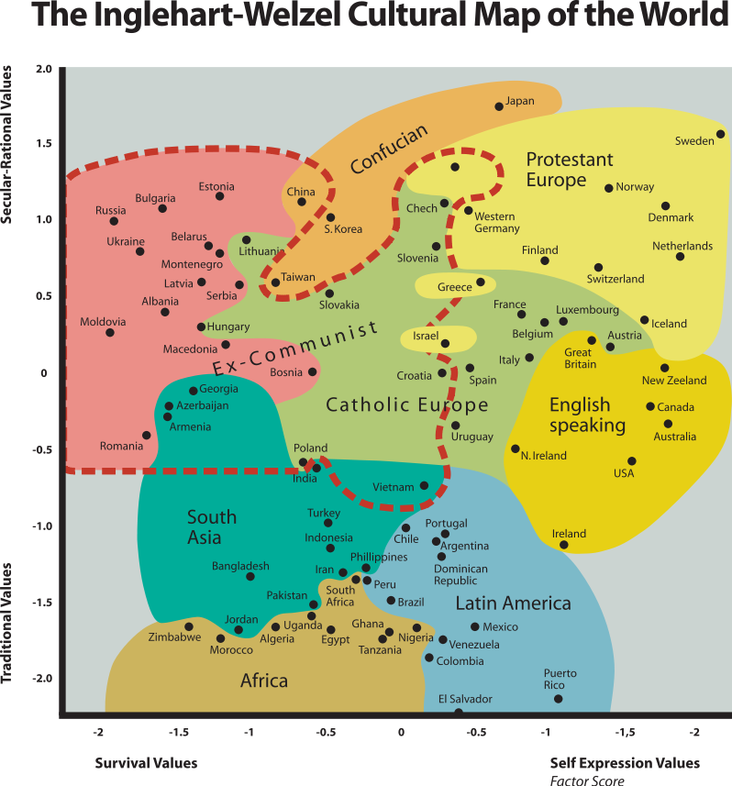

The current presentation, based on the results of both large international projects, is focused around three basic questions:
- Are the values of young people (18-25) different from the ones shared by the rest of their compatriots? To what extent are they different?
- Can the ‘culture shift’ be observed in the seven countries of Eastern Europe and Caucasus? How do young people place themselves in the picture?
- What is common and what is different in terms of the values shared by young people from the seven countries?

Numerical analysis

Some ‘hard data’ reflecting the economic and demographic situation of the seven countries will provide a good context for future discussions on values. The data are presented in Table 1. The comparison of Poland (one of the new EU countries) and Germany (one of the richest EU countries) illustrate well the situation in the region.

Table 1.
Basic economic and demographic data for 7 countries (compared with Poland and Germany)
 | population (thousands) | % of population  in age 0-14 | GDP per capita  (2008, in USD) | HDI*  (rank in 179 countries)
Armenia | 2 967 | 18,2 | 6 400 | 83
Azerbaijan | 8 238 | 23,9 | 9 000 | 97
Georgia | 4 615 | 16,1 | 4 700 | 93
Belarus | 9 648 | 14,3 | 11 800 | 67
Moldova | 4 320 | 15,9 | 2 500 | 113
Russia | 140 041 | 14,8 | 15 800 | 73
Ukraine | 45 700 | 13,8 | 6 900 | 82
Poland | 38 482 | 15,0 | 17 300 | 39
Germany | 82 329 | 13,7 | 34 800 | 23
* stands for Human Development Index
Data source: CIA World Factbook (www.cia.gov) and UNDP (hdr.undp.org)

The data show that:
- the societies are quite young – this is especially true for Caucasus countries; and
- there is quite marked differentiation in the standard of living as expressed by GDP per capita and HDI. The richest countries are Russia and Belarus, while Moldova is the poorest. Ukraine and Caucasus countries, meanwhile, occupy intermediate positions.

The importance of various values in life

In order to have a general overview of the similarities and differences in the value systems of the seven societies under study, let us look at the relative importance young people attach to such areas of life as family, friends, leisure time, work, religion and politics. The general pattern is similar in all countries; however some of the differences are significant.

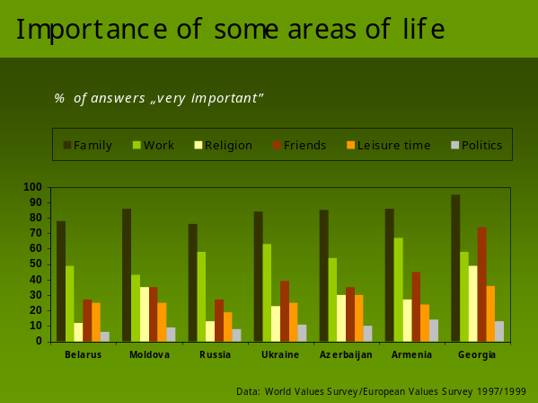 | Family received the highest scores on the importance scale in all the countries, but in Georgia nearly 100% indicated it is as being “very important”. Moreover, Georgia is the only country where friends were considered more important than any other area of life besides family.
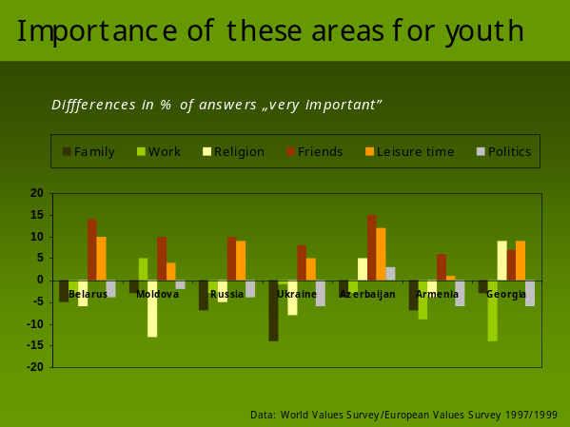 | The next slide shows how young people’s attitudes differ from the wider population. Negative percentages mean that the share of answers scored as ‘very important’ is lower among youth than in the population as a whole. Where the value is positive, youth more often than the total population perceives certain areas of life as ‘very important’. Again, one can notice many similarities between countries: everywhere young people are more likely to attach higher importance to leisure time and friends and less value to family life.
In two countries – Georgia and Azerbaijan – youth more often attach higher importance to religion than the population as a whole. In the case of Georgia we also have newer data and can observe that the same situation obtained in 2005 (when the last available survey was conducted).

Self-expression and traditional values

In the World Values Survey the attitudes towards materialist and post-materialist values were measured by asking the respondent which of the listed qualities should children be encouraged to learn at home.
The qualities are listed below:
- Good manners
- Independence
- Hard work
- Feeling of responsibility
- Imagination
- Tolerance and respect for other people
- Thrift, saving money and things
- Determination, perseverance
- Religious faith
- Unselfishness
- Obedience

Those values that have been highlighted were used in the following analysis in order to check which sets of values – post-materialist or materialist – seem to be more attractive for respondents from the seven countries under study. ‘Hard work’, ‘thrift, saving money and things’ and ‘obedience’ are ‘materialist’ values, while ‘independence’, ‘imagination’ and ‘tolerance’ are regarded as post-materialist.

I have constructed simple indices of both groups of values: every index represents a sum of qualities from certain value groups that were chosen by respondents. This means that each index could vary from 0 to 3 (where 0 means that no quality from a certain group was chosen by a respondent and 3 means that all of them were chosen). I have then calculated the mean values for each index and for each country, taking into consideration both the entire population and youth only (people not older than 25 years). The results of these calculations are presented on two-dimensional ‘maps’ showing the relationships between countries from the viewpoint of two indices at the same time.

For all 7 countries (survey 1997/1999) | For 4 countries only (survey 2005/2007)
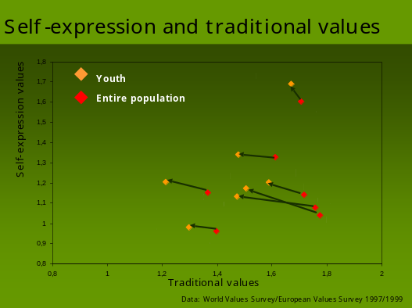 | 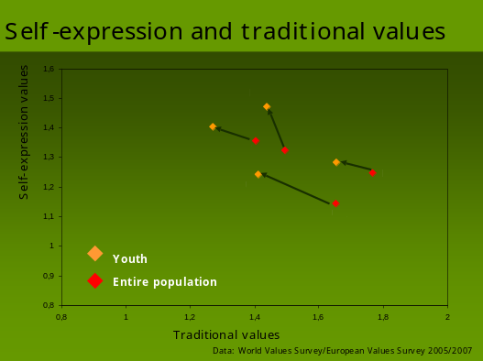

When reading the presented ‘maps’ please note that the closer the arrow is to the vertical line connecting the point representing youth with the one for the total population, the smaller the difference in terms of sharing traditional values. By the same token, the closer the arrow is to the horizontal line, the smaller the difference in sharing self-expressive values. The length of the arrow represents the relative value of the difference.

The maps show that regardless of the survey date, youth showed a less traditional set of attitudes and instead favoured values of self-expression in comparison with the population as a whole. However the differences in sharing traditional values were greater than in the case of self-expressive values in nearly all of the countries. The notable exception was Moldova (in both survey waves). It is worth highlighting. however, that when we measure the attitudes towards some values of self-expression in ways that are different to those presented above, the picture becomes less clear. Youth is not always and not everywhere more attracted to values of self-expression than the population as a whole.

Let us now look at such commonly used measures of post-materialist or self-expressive values as the attitudes towards gender equality and tolerance of homosexuality. The attitudes towards gender equality were measured by seeking opinions about the statement: “Both men and women should contribute to the household income”. The tolerance for homosexuality, meanwhile, was measured by the following question: “Please tell me for each of the following actions whether you think it can always be justified, never be justified, or something in between”, using a 1-10 scale. Homosexuality was duly listed in these ‘actions’.

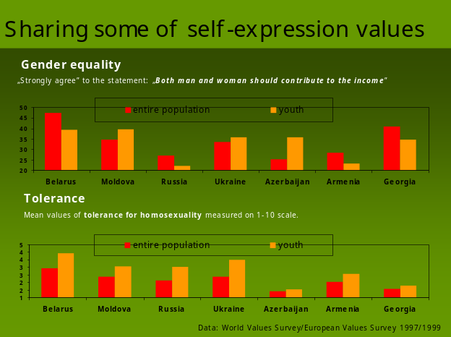 | The results show that only in three countries does youth support this aspect of gender equality more than the population as a whole. These countries are Moldova, Ukraine and Azerbaijan. In the remaining four (Belarus, Russia, Armenia and Georgia) youth seemed to be more conservative than wider society.  When speaking about tolerance for homosexuality, in all the countries youth expressed more tolerance then the population as a whole.
It is worth noting that the respondents from Caucasus countries appeared to be less tolerant of this kind of sexual orientation than those from Eastern Europe.

Political values

Last, but not least, the set of values that I would like to present here relate to the political and economic system. Inglehart (2005) claims

“societies that rank high on self-expression values also tend to rank high on interpersonal trust and have relatively high levels of subjective well-being. This produces an environment of trust and tolerance, in which people place a relatively high value on individual freedom and self-expression, and have activist political orientations – the attributes that the political culture literature defines as crucial to democracy”. (Page reference?)

These words, however, concerned West European societies. The seven countries with which we are concerned are transition countries where living standards and the level of economic development is radically different from Western Europe. It is interesting, though, to consider the level of support for democracy in these countries. What do young people think about democracy? This is important, because young people’s attitudes on this subject are hugely influential on how democracy is viewed within these countries. It is especially interesting in light of Inglehart’s belief that ‘under conditions of economic or physical insecurity, people may be willing to submit to authoritarian rule, but with rising levels of existential security they become less willing to do so’. (p. 140)

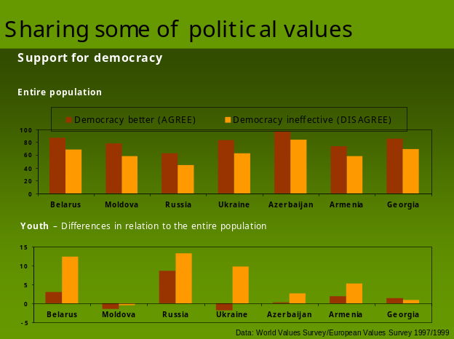 | The graphs show support for democracy measured in two ways: 1) as the attitude towards the statement that ‘democracies may have problems but they are better than any other political system’ (those who AGREE are considered pro-democratic) 2) as the attitude towards the statement ‘The economic system works badly in democracy’ (those who DISAGREE are considered pro-democratic).
The graph for youth shows the difference in percentage terms between youth and the total population. One can see that in 1997 Moldovan youth was a little less democratic than the wider population (however the difference was very small). Small differences had been recorded also for Georgia and Azerbaijan.

Figure? Correlation between the support for democracy and the value of Human Development Index
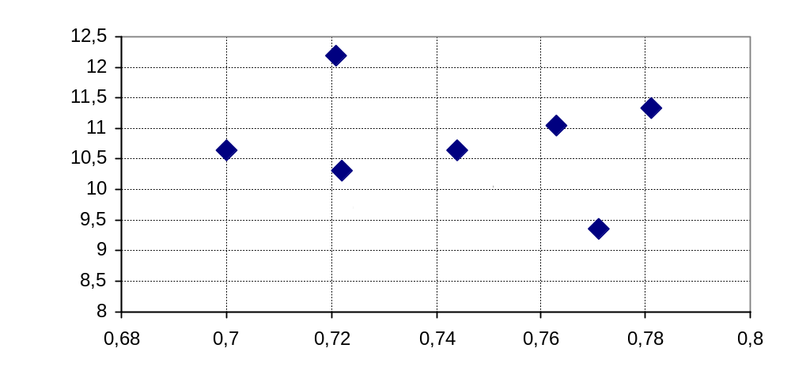

The above figure presents the relationship between the value of Human Development Index (UNDP) and the index synthesising various aspects of support for democracy (calculated from the data of WV 1997/1999). If Inglehart’s hypothesis was true for transition countries one should observe a virtually linear distribution of countries, which would mean that indeed higher living standards imply higher support for democracy. There are, however, several exceptions to this rule. The support for democracy in Moldova and Armenia is substantially higher than could be inferred from their human development levels. The support for democracy in Russian society, moreover, appears to be visibly lower than we would expect on the basis of this country’s living standards measured by HDI.

As I am speaking about transition countries, let us turn our attention to attitudes towards the market economy. There are only minor differences between the countries under study. The graphs for the entire population show mean values on the 1-10 scale of support. The graphs for youth show the differences in mean values between youth and the entire population.

In 1997/1999 | In 2005/2007
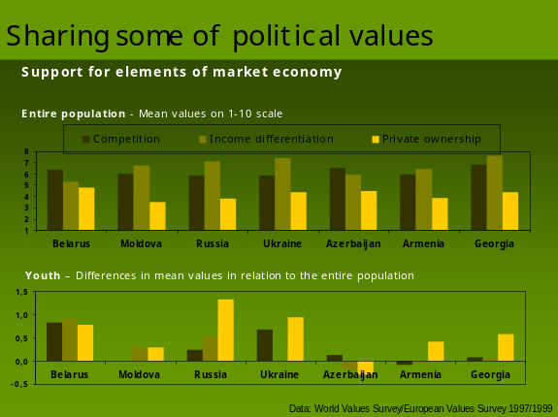 | 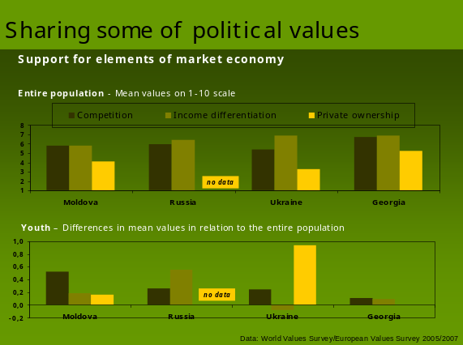
In the vast majority of these countries youth demonstrates higher support for nearly all elements of the market economy.

The last point on this particular subject is another ‘map’ showing the relationship between support for democracy and the market economy, both in the seven societies taken as a whole and in the youngest sections of the population in these countries. Unfortunately calculation of the same indices can only be based on the available comparative data, which is quite old (1997/1999).

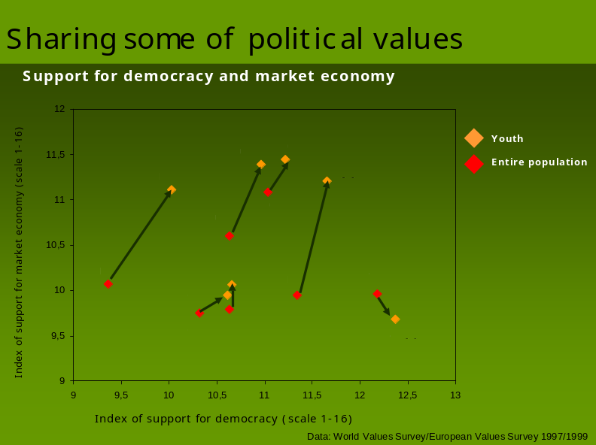

The interesting point about this ‘map’ is the behaviour of youth in Azerbaijan. It is the only country where young people give less support to the market economy than the population as a whole. Belarus and Russia are different from the remaining countries: the distance between youth and the population as a whole is quite marked. It is interesting, however, that this distance appears mainly to be due to the differences in the levels of support for the market economy rather than for democracy. This might suggest that these societies could support market reforms without democratisation.

This presentation should be regarded as s starting point for discussion. Let us, then, start the discussion with trying to answer the following questions:
- Do you see these data outdated or are some of the elements in the picture presented still valid?
- Do you see studying and analysing the value systems as useful for your work on youth policy development? Maybe you would like to encourage sociologists from your countries to perform more in-depth analyses of the presented data?

References

Data sources:
- World Values Surveys 1995/1996, 2000/2001, 2005/2007
http://www.worldvaluessurvey.org/
- European Values Survey 1999/2000
http://www.europeanvalues.nl

Literature:
- Inglehart, Ronald (1971). ‘The Silent Revolution in Europe: Intergenerational Change in Post-Industrial Societies’, American Political Science Review, 65:4, 991–1017.
- Rokeach, Milton (1968). Beliefs, Attitudes and Values. San Francisco: Jossey-Bass.
- Jasinska-Kania, Aleksandra, Marody, Miroslawa (eds) (2004), Poles among Europeans, Wyd. Naukowe Scholar, Warsaw.
- Inglehart, Ronald and Christian Welzel, Modernization, Cultural Change and Democracy. New York, Cambridge University Press, 2005: p. 64
Appendix 7: PowerPoint Presentation of Youth Policy in Armenia

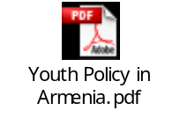
Appendix 8: Seminar Participants’ Expectations:

During the round of introductions to the Seminar participants were asked to identify themselves and say a few words in relation to their expectations of the event. This part of the session was enhanced by an exercise in which people wrote down their expectations on pieces of adhesive paper; these were then placed on the wall of the Seminar Room. The comments can be divided broadly into two main themes. The first highlights the virtues of simply bringing people together. It evidences the intrinsic value of sharing information, comparing experiences, developing analyses, exchanging ideas and simply networking. The second theme, arising from the activities of the first theme, involves translating ideas into concrete action. All of the participants, it has to be said, understood the close relationship between the two themes and this is reflected in the comments. Set out below are the expectations shared by participants. It is difficult to group the comments neatly into thematic categories, but an attempt has been made to organise them in line with the afore-mentioned organising principle.

The Importance of Information Sharing and Reflection:

“ To discover youth policy realities in EECA”

“Understanding the current situation with youth policy in the region.

“Better understanding of the situation and needs of young people.”

“To find out the countries’ good practices in the youth field.”

“To reflect and contribute with knowledge on local realities and link them with the European dimension.”

“To exchange information regarding youth work and youth policy.”

“To analyse and compare the levels of youth work development in the countries.”

“To get an overview of youth policy in other countries.”

“To share new information from EECA countries and update information about Georgia.”

“To share the results of the research we have done in 2009 in (our country) and to make it more visible.”

“To get an overview of the institutional approaches to youth policy in EECA (from the Partnership).”

“To understand the integrated processes in the region.”

“To get to know youth policies of the countries of EECA Region and to compare them with my context…. Because youth policy issues are my learning project for the coming year or two.”

“To update the priorities of (the) Eastern Partnership and Caucasus.”

“To understand what is being done by the authorities to overcome problems of the region (visa barriers, double standards, etc.).”

“To discuss the new perspectives of Europeanisation.”

“To meet again the partners.”

“Sharing experiences.”

“Sharing good practice.”

“(To find out…) …how government sectors deal with NGOs in EECA Region.”

“Exchange views.”

“Meeting in person participants of EECA policy stakeholders.”

“Getting to know …recent developments in youth policy of the region and maybe get some inspiration.”

The Importance of Translating Information and Reflection into Action:

“Networking between institutions and stakeholders from EECA region countries.”

“To develop new partnerships within EECA”

“To identify common grounds for partnership and co-operation between EECA with other European regions.”

“To meet new people from partner countries and share experience.”

“To learn how to deal with such a variety of stakeholders and such a large scope and such a short time period.”

“More connected work between youth policies and resource centre (and) Youth Partnership.”

“To establish contacts and discuss ideas and future projects for my country.”

“Achieve concrete results and proposals for action.”

“(Learn…) How to influence mainstream youth policy of Europe into Ukrainian policy.”

“To involve Belarusian stakeholders in the process of common youth policy development in the region.”

“(Setting) Clear objectives for the future.”

“To find new ways of YFJ support in development of youth policies in Eastern European and Caucasus countries.”

“(To…) …find practical ways of translating the answers to needs into policies.”

The Inextricable Relationship between Reflection and Action

“I hope in future we’ll have good co-operation.... As this is my first working visit/seminar I expect more of situational analyses and the development of networking.”

“To link the

- Stakeholders
- Policy trends and developments
- Concrete networking and actions.”

“Fruitful result by joyful process.”

“(Gaining…) ... motivation and inspiration for follow-up initiatives.”

The above list of written expectations were placed on one of the walls in the plenary meeting room and remained there for the duration of the Seminar.
Appendix 9: Evaluation of Seminar

SEMINAR
YOUTH POLICY DEVELOPMENT
in Eastern Europe and Caucasus

Konstancin Jeziorna, Poland, 6th-9th July 2009

EVALUATION QUESTIONNARIES

Number of received questionnaires – 10

Questions:

- What were the best elements of this seminar for you?
- What was the challenge for you at this seminar?
- What could have worked better here?
- What would you like to change in the concept of such events of the future?

Answers:

1) What were the best elements of this seminar for you?
- the possibility to find out more detailed information about EECA Country YP
- to meet people interested and dealing with research in YP field
- yesterday visit to Warsaw :-)

I liked very much library, it had useful information in the field of YP which will help me for YP development in my country.

Clear picture of situation in the countries. What needs have small NGO’s.

The flexibility of the agenda, professional skills of the participants.

Firstly – mapping the situation in the region. That was important for me to see differences and similarities. Secondly – possibility to work in groups on the most hot issues like “Eastern partnership”. I believe that there will be a lot of cooperation in nearest future.

The group was very diverse in terms of sectors, statuses, but still they were quite motivated to reflect on common issues and to come to practical solutions.

- Info update on the policies and structures of CoE&EC (policies, programs, mechanisms, trends etc.)
- Empowering human relations started during the last seminars.
- Increased confidence in communication with colleagues from Azerbaijan and some practical steps towards work on conflict resolution.
- Feedback from our side on the ways ENPI EP works in the countries and reflections on the way of improvement.

- information exchanged – very useful
- present people – at the seminar were more people that could provide more information than at last seminar. At the last seminar we didn’t really map the whole region
- the support – with information from Youth Partnership Program and Salto RC for EECA

The best elements of the seminar was, above all, the opportunity to learn and to share. This was my first time to get to know what is going on in the youth field in EECA region. Another best element for me was the presentation & communication with Joanna Konieczna-Salomatin. The issue she addressed/raised have given lots of thoughts about values and about frames of references between young people in the region. One more best element is open space element for me this gave the ground for follow-up.

- meeting people I know & did not know
- up-date on European youth policy of Hanyo
- meeting real vice-minister of Armenia
- getting overview of the youth policy in EECA

2) What was the challenge for you at this seminar?
- to talk about youth policy without people taking decisions in countries
- to start things from zero though a lot of things had been done before – I am lacking complexity & continuanity

The challenge for me was to deal with youth policy on my own (about youth policy of Ukraine) as I was expecting to discuss and share views with someone who is in the policy field. I was worried that the view of youth policy I presented is not full and reflect only my vision and feeling of it. Though the group and team was supportive and it helped me to get ideas for the future and to draft “action plan” for myself.

- to compare the level of youth policy developments in each countries
- to identify new tools and instruments for policy development and research
- to receive support for personal ideas and actions were to start and with what

- Not equally representative delegations from the countries (e.g. a local YNGO from one country and NYC from another).
- Lack of motivation from couple of national delegations to concentrate on work and not relaxation and showing-up.
- Lack of time to work on the things in more details (regular problem :-)

The main challenge for me as a newly appointed deputy minister and new person in international youth policy was to understand the framework of our international cooperation and to understand what I can contribute in here for further development as a civil servant.

In my case the challenge is still the same – to involve authorities into cooperation.

Not to do the same as in the previous events like this

It was I little bit difficult, cause not every country was represented full and from some countries were only representatives of small NGOs which do not have much information about youth policy in the country, but in any case I think we succeed.

My challenge was to properly deliver the needs of my country to the participants and get as many feedbacks as possible.

- to establish the way for use best practices in my country
- to identity the tools of cooperation with decision makers in my country

3) What could have worked better here?
Activity to be focused on more detailed topic
- how to get the real country situation in YP
- how can be “motivated” country decision makers to improve their situation.
- to identify more concrete way of country initiative support (inclusive financial)

I think that methodology used there worked good.

Next step must be concretely continuing all the work which has been done.

Everything was good.

The seminar was very well organized. The only problem was to get together all 3 actors from each country.

I guess it will be good to put more efforts in having state representatives from all the countries which will definitely contribute to the follow-up of the results of the seminar.

- work more intensively on involving civil servants
- a bit of more free time (e.g. longer lunch breaks)
- the templates or any homework for the event should be sent earlier and followed-up for “having done”

- if at the table were present ministry representatives from more countries

What could have worked better? Only the opportunity to meet other stakeholders from my country. The content, logic and the process of the seminar were OK for me. As well the work in international groups on the second day could have worked better for me if I had more information about youth policy development in my country.

The final outcomes could be at more “political” level than just an activity.

4) What would you like to change in the concept of such events of the future?

- I guess it is important to have more concrete expected outcomes before such events as well as more concrete objectives.
- I also feel that partnership should find its specific role in the whole process – not to be repetitive and overcross with EC and CoE.
- I think one of the best solutions to increase the level of participation of officials would be to ask assistance from us – youth workers – to content those who are our partners in our regions and to work on this “people to people” level. But it also requires from partnership more defined role in this process – what level you would like to work on (regional, federal, international?).

Again, the idea of the meetings like this is wonderful if the whole triangle of stakeholders is represented. If it will be possible in the future to gather representatives of all three stakeholders would be perfect. But I afraid that if we make these meetings shorter and in a form of conference it may be lack of inputs from the experts and lack of time to present recent developments and latest concepts.

I don’t know. Since this format for me is very good. May be more time for personal proposals and discussions. But generally I like the format and I think it is enough time allocated. Thank you very much for such opportunity and support. We have improved.

- Thematic scope (maybe?)
- Project work for follow-up planning can be more focused. Like in this one we could work on any ideas. Less “open space” in terms of thematic.
- To reflect on this one before starting the next one (during the event or even earlier)

From theoretical discussions we should quickly pass to practical implementations of concrete actions with the support of EC and CoE.
I want also to add that I am quite grateful to the organizers (Andrij and Marta) for providing such a great atmosphere and conditions.

Probably it will be a good idea to organize a bigger event on Youth Policy. More countries! Then it will probably motivate authorities to take part.

Maybe more or less concentrate on the relevant statistics and data.

For now concept is working, maybe it can be changed later and be suitable to situation.

I think it would be good if we could find space for presentations of already existing cooperation and events which had concrete results and effected on development in the region.

Before such kind of seminar to organize a country researchers meeting, in order to prepare a realistic picture/report on country YP.
The YP research and analytical dimension to be more explored in dialogues with EU institutions and country stakeholders.

Followed by the Council Resolution of 27 November 2009 on a renewed framework for European cooperation in the youth field (2010-2018).
Decree 598 of the Prime Minister dated December 8, 1997 contemplated the creation of a youth specialist’s function in the staff of each Marz Governor’s office (Marzpetaran).
Up to now (2009) there were four waves of the World Values Survey. The detailed information on the project, its organisation and main findings, as well as raw data for download, is available on the project’s website: www.worldvaluessurvey.org
More about the history of the European Values Survey can be found on the project’s website (www.europeanvalues.nl) as well as in the book edited by Aleksandra Jasinska-Kania and Miroslawa Marody “Poles among Europeans”, Wydawnictwo Naukowa Scholar, Warsaw 2004.
These two measures of living conditions are strongly correlated as GDP per capita is one of the components of HDI.

