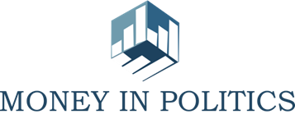
Regional Conference 2017

Lasting Challenges and
International Practices in Eastern Europe

Political Party/Campaign Finances and Use of Administrative Resources in Moldova

Country Report

Author: Nicolae Panfil, Promo-LEX Association

Chisinau 2017

BACKGROUND INFORMATION

The regulatory framework on political parties and election campaign funding in the Republic of Moldova is composed by the following Laws and regulations:
- the Constitution of the Republic of Moldova,
- the Law on Political Parties (Law No 294 of 21 December 2007),
- the Electoral Code,
- the Annual Budget Law,
- the Regulation of the Central Electoral Commission (CEC) on Political Parties Financing,
- the Regulation on Use of Cash Registers (CR) for Cash Settlements,
- Tax Code & Contravention and Criminal Codes,
- other regulations and instructions of different authorized institutions.
The current legal framework on political parties and election campaign funding is the product of a long lasting and intense work conducted by different stakeholders, including Central Electoral Commission, the Parliament and Government of Moldova, and not less important – civil society organizations and experts specialized in election observation, monitoring of political financing and combating corruption, who contributed altogether to the improvement of the transparency and disclosure rules for political parties and election candidates.
An important trigger mechanism for the reform in this field was the Evaluation Report on Moldovan Transparency of party funding and recommendations formulated on April 1, 2011 by the Group of States against corruption (GRECO) of the Council of Europe in the as well as by the findings and recommendations included in the election observation reports of the OSCE/ODIHR.

LEGISLATION AND POLICY ANALYSIS
As a result of the efforts for the improvement of the regulations on political financing, on April 9, 2015, the Parliament adopted a set of amendments to the Law No 294 on Political Parties, Electoral Code, Criminal and Contravention Codes. The most profound changes that aimed at enhancing transparency of political parties financing and, implicitly at improving the dynamics of their activities referred to the following aspects:
- the system of political parties funding was changed from exclusively private funding to a mixed system, in which the private funding is complemented by subsidies from the state budget, offered to the eligible parties from January 1, 2016;
- new provisions on the management and transparency of political funding, either public or private, were imposed in the Law No 294;
- palpable improvements to the legal framework in terms of reporting, disclosure and oversight of the political parties funding;
- sanctions for the infringement of the political funding regulations were provided in the Law No 294, and gradual sanctions were detailed in the Contravention and Criminal Codes;
- the CEC was vested with the responsibility to supervise and control the political parties funding. This mandate was transferred from the Ministry of Justice (MoJ) to the CEC with the intention to ensure uniform and continuous control both over the political parties and election candidates’ finances.
The changes introduced to the political finance legislation were welcomed by GRECO, which assessed that “[t]he Republic of Moldova now has a legal framework which aims to ensure transparency in the funding of political parties.”
The further changes adopted in 2016 and 2017 with regard to political parties financing can’t be assessed as massive as the one conducted in 2015. Specifically, there should be mentioned the following amendments made to the Law No 294 and CEC Regulation on political parties’ finances:
- There was excluded the obligation of the political parties to follow the Law on Public Procurement when goods or services are bought from the state budget allocations. Promo-LEX Association appreciated this modification as a regress because the Law on Public Procurement was expected to impose the general principles according to which the tender procedures had to be open and fair, as well as to combat eventual corruption situations;
- Political parties can spend now more money for the services and goods that can be reported as “other expenses” due to the increased capacity of this budget line from 10% to 30%; this change offers, on one hand more flexibility to the political parties on reporting their costs, but on the other side it may be also used for not reporting properly all the costs or for underreporting some type of the expenses. Such a permissive change is also contrary to the GRECO Recommendation (i) - “annual financial reports destined for publication and submission to the supervisory authorities to include more precise information, guaranteeing a full overview of the party’s assets and its income and expenditure”;
- There were made some amendments to the Election Code addressing the financing of the activity of the initiative groups’ (signature collection) before the start of the election campaign for the President;
- The sanctions for a series of contraventions on political parties and election campaign financing were reviewed in November 2016. Looking at the revised amount of the fines, someone may consider that authorities decided indeed to impose more severe sanctions. Well, this is only partially true because in reality, the value of different sanctions, if measured in administrative units, got reduced and the increased value of sanctions, calculated in money, is determined by the increase of the value of the administrative unit from MDL 20 to MDL 50.

Revenues and expenditures for party and campaign financing
The article 25(1) of the Law No 294 on Political Parties and the CEC Regulation on Political Parties Funding stipulates the following funding sources of political parties:

- Membership fees
The membership fees are compulsory payments to ensure the continued membership of the political party. The obligation to pay membership fees is stipulated in the Article 186 of the Civil Code of the Republic of Moldova. According to the Law on Political Parties, the amount and method of collecting the membership fees is established by the party’s statute and, together with the total amount of annually accumulated contributions by the party, shall be published on its website and on the website of the Central Election Commission.
In 2016 Promo-LEX Association conducted a comprehensive study on the “Strategies, Practices and Tools for financing political parties in Moldova” and pursuant the analysis of 43 political parties’ statutes, approx. half of the political parties (22 of 43 political parties) have the membership fees specifically regulated in their statutes, while other 18 parties have the membership fees specified in other internal party regulations, and 3 parties didn’t have at all provisions regarding membership fees. In practice, in 2016 the membership fees accumulated by the political parties amounted MDL 10,326,459 (approx. Euro 468,320.13) and the share of this source of funding faced gradual but stable decrease from 37% in 2013 to 11% in 2016. Such a trend poses specific concerns, especially if looking at the article 87 of the CEC Regulation that offers the institution the right to suspend the transfer of state subsidies in case of non-payment of membership fees by more than half of the members of the party during a year. Additionally, given the fact that there are no upper limits for membership fees, it is of high importance that both the legislation and political parties clearly distinguish the membership fees from donations, thus ensuring that the donations’ limits are not bypassed. According to Moldovan legislation the ceiling of annual revenues of a political party originated from membership fees and donations cannot exceed the equivalent of 0.3% of the revenues scheduled in the national budget for that year.

- Donations
Donations can be: a) money other than membership fees; b) donations in the form of property, goods, services provided free of charge or on better terms than the commercial (market) value, payment for certain goods and services used by the party. These donations shall be reflected in political party’s accounting records at their market value, not exceeding the limits provided for in the Articles (4) and (5) of the Law on Political Parties. The limits of donations are set at the level of 200 and 400 average salaries for private and legal entities. The average salary for the year 2016 was set at 5,050 MDL. It should be mentioned that the draft law on political parties funding elaborated within a working group established by the CEC with participation of different stakeholders provided for a threshold of donations of 20 average salaries for individuals, and respectively 40 for legal entities, but were unjustifiably increased 10 times by the MPs during Parliamentary debates.
The analysis of the annual financial statements for 2013, 2014, 2015 and 2016 presents the donations as key funding source of the political parties. This type of income has evolved from the share of 55% in 2013 to 76% in 2014, and then suffered a constant decrease – to 61% in 2015 and to 49% in 2016. This regressive phenomenon is also relevant for the donations from the legal entities - from 8% in 2013 to 6% in 2015 and to 1% in 2016.
In 2016 the donations ceilings amounted to MDL 1,010,000 (approx. Euro 45,805) for a private person and MDL 2,020,000 (approx. Euro 91,610) for a legal entity. Per total, in 2016 donations amounted MDL 48,172,775 (approx. Euro 2,184,706.34), of which 49% from individuals and 1% from legal entities. It is unlikely that such high levels of donations will serve the purpose of diversifying the political parties’ sources of income or will motivate the parties’ to collect them at the grassroots level. Instead, such generous ceilings for donors may lead to “a deeply worrying trend of money in politics drowning out the voices of ordinary citizens”.
In line with the newly amended Election Code, article 38(1), only financial resources related to the work, entrepreneurial, scientific or creative activity carried out on the territory of the Republic of Moldova may be used. This provision is valid both for financing of political parties and election campaigns, which means that the Moldovan migrants leaving and working abroad are not allowed to financially support those parties and/or candidates they sympathize with, thus not encouraging them to fully exercise their rights as citizens. However, Venice Commission specifies that “this prohibition should not prevent financial donations from nationals living abroad”. The fact that “citizens cannot donate out-of-country income, may constitute a disproportionate restriction on political participation” was noticed by the OSCE/ODIHR observers during 2015 general local elections.

- Subsidies from the state budget
The volume of allocations constitutes up to 0.2% of the State Budget revenues and is approved every year together with the adoption of Annual Budget Law. Allocations from the state budget shall be monthly distributed by the CEC among parties that took part in the parliamentary and general local elections (50% to 50%), in proportion to their performance. The Law also provides for distribution of allocation in case of electoral blocks. The members of a block have to come to a preliminary understanding or, in the absence of an understanding, the allocations will be calculated based on the number of mandates obtained by each component of the block.
The volume of monthly subsidy for previous year was established by the CEC on 18 August 2016 in the amount of MDL 1.11 for each valid vote obtained during parliamentary election of 30 November 2014, and of MDL 0.47 for general local elections of 14 June 2015. Respectively, in 2016 the state subsidies have changed the balance of revenue sources and amounted MDL 37,850,883 (39% of the total revenues, approx. Euro 1,887,824.58). Subsidies allocated from the State Budget were supposed to be transferred monthly to specially designated bank accounts, but in reality were allocated for eligible parties starting from the 3rd quarter of 2016.
Funds from the State Budget that were not used in the current budget year will be available for use in the following years. Political parties lose their right to allocations from the State Budget if their activity is limited, or the party lose its legal personality or if the party is in process of liquidation.
Speaking about state funding of political parties, it should be recalled that, “at the stage of drafting the amendments to the Law no. 294, the bill included financial incentives meant to ensure gender balance at a ratio of 20 per cent of the total computed amount of public funds, proportional to the performances at both parliamentary and general local elections”. Unfortunately, the respective provisions were not endorsed.

- other revenues
Political parties may also obtain income from legitimate funding sources that are not prohibited by the law and that are provided for in the statute of the party. The respective income is exempt from taxes or is taxable according to the Tax Code. The share of “other revenues” in 2016 was insignificant – MDL 1,713, constituting less than 1%.

Regulatory authority and provisions for political parties’ and election campaign financing
The change of the institution to which the reports are to be submitted - from the Ministry of Justice to the CEC represents one of the main aspects of the political financing reform conducted in April 2015. Accordingly, the Central Electoral Commission became the body that is responsible for the supervision and control of both political parties’ and election campaign financing. This change was welcomed by GRECO, which assessed that “CEC offers more statutory guarantees of independence than other bodies” and is expected to have a better overview of various aspects of political financing.
With regard to the subsidies for political parties from the state budget, the Venice Commission recommends that public funding is provided “on condition that the accounts of political parties shall be subject to control by specific public organs (for example by a Court of Audit). States shall promote a policy of financial transparency of political parties that benefit from public financing”. Respectively, the Law on Political Parties (articles 28.5 and 30.2) provide that the control of the allowances received from the state budget is exercised by the Court of Accounts.
The above mentioned institutions shall issue instructions and detailed guidelines on transferring, receiving and recording donations, the non-financial contributions obtained by political parties, and on their use in compliance with the legal requirements, as well as on other issues related to the funding of political parties and of election campaigns.
In this regard, on December 23, 2015 the Central Electoral Commission adopted the decision no. 4401 on the approval of “The regulation on financing of the activity of political parties” which present in details all the aspects of political parties financing in Moldova. The Regulation provides in the annexes the format of the report as well as other forms that have to be presented to the CEC:
- Registry of party membership fees,
- Registry of donations from individuals and legal persons,
- Register of donations in the form of property, goods, free services or under more advantageous conditions than the commercial value,
- Statutory declaration on the non-existence of state, foreign or mixed share in their share capital and on the lack of legal limitations;
- Information on cash flow.
Thus, the report on political parties’ financing clearly distinguishes between income and expenditures and includes itemization of donations into standardized categories with identified nature and value of donations. Also, in the electoral years, the reports include both general party finance and campaign finance. The above mentioned provisions are set in the article 29(4) of the Law on Political Parties and were positively assessed by GRECO during Moldova’s Third Evaluation Round.
Political parties, whose annual income or expenses exceeded one million MDL should require an external accountant to conduct an internal audit of party’s finances at least once every three years (article 31 of the Law on Political Parties). The audit should be done and submitted to the CEC together with the annual financial report, as well as to the Court of Accounts, in case the party received allowances from the state budget. Although in general this provision is in line with GRECO recommendation to establish an external audit, the Moldovan authorities were recommended “to consider imposing more regular audits”.
Article 29(1) of the Law on Political Parties require the financial reports to be submitted to the CEC every six months, as well as an annual report by March 31 of the following year. Similarly, the reports are to be submitted to the Court of Accounts by the political parties that received allowances from the state budget. The CEC have the right to request additional information and/or clarifications from the political parties and public or private institutions for verification purposes. In such cases, the information should be provided within two weeks. The reports should be made public on the CEC website within 48 hours after the receipt and acceptance, as well as on the websites of political parties.
Moreover, by the date of 10th, political parties are required to submit to the CEC monthly information (in electronic format) on party’s expenses paid from the state budget (article 66 of the CEC Regulation on Political Parties Funding). This way CEC can verify how parties manage the public money and compare the information included in monthly statements with the information reflected in the annual and semi-annual statements. So far, CEC apparently did not report any deviations or discrepancies between the information included in the monthly statements and the totals from the annual and semi-annual reports. It should be also mentioned that, starting from 2016, CEC shall also annually submit to the Parliament, by June 1, a report on the funding of political parties and election campaigns.
As far as election campaigns are concerned, their direct and / or indirect financing is governed by the following conditions:
- the electoral contestant should open a special bank account entitled "Electoral Fund" and transfer own financial means as well as other money means received under the conditions of the law from individuals who are citizens of the Republic of Moldova or from legal persons from the country;
- the account with the mention "Electoral Fund" may be opened until the registration of the electoral competitor, provided that any receipts and expenses on this account are made only after the registration of the electoral competitor;
- the electoral contestant who does not open a special bank account informs the CEC about this and may carry out campaign activities or electoral promotion that does not involve financial expenses;
- the general ceiling of the financial means that can be transferred to the "Electoral Fund" account shall be established by the CEC, taking as a basis of calculation a coefficient multiplied by the number of voters in the electoral constituency in which the elections take place;
- the ceilings for donations from individuals and legal entities in the "Electoral Fund" account for an electoral campaign are 200 and 400 average monthly salaries for the respective year;
- cash donations by individuals shall be accompanied by a completed form attached to the supporting documents of the electoral contestant. The model of the cash donation form is approved by the Central Electoral Commission;
- legal persons may transfer money to the "Electoral Fund" account only by transfer together with an informative note about the non-existence of the state, foreign or mixed shares in their capital and with a declaration on own responsibility regarding the lack of such restrictions;
- the financial means from the electoral fund may be used only after they have been declared to the CEC or to the district electoral council in the case of independent candidates in the local elections;
- the funds transferred to the accounts with the mention "Electoral Fund" cannot be used for personal purposes;
- all expenses for the electoral campaign shall be made by means of the account with the mention "Electoral Fund";
- electoral contestants are forbidden to offer voters money, to distribute without charge any material goods, including from humanitarian aid or other charitable actions. This provision shall not apply to symbolic gifts representing electoral or political advertising, made out of means declared on the "Electoral Fund" account, bearing the symbol of the electoral contestant and with the market value not exceeding 2 conventional units (1 unit = 50 lei; in 2016 it constituted 20 lei).
- within 5 days from the beginning of the electoral period, the broadcasters are obliged to publish the conditions in which they offer advertising space (including the price / minute) and other related services to the electoral competitors, informing the CEC and the Audiovisual Coordination Council. The Central Electoral Commission publishes this information on its official website;
- the provisions of the Electoral Code regarding the conditions, the manner, the restrictions and the responsibility for financing of electoral campaigns of the candidates in the elections, of the electoral contestants and of the referendums shall also apply accordingly to the initiative groups. The Regulation on the financing of initiative groups for collecting signatures in support of an elective candidate or for the initiation of a referendum is approved by the Central Electoral Commission.
The financing or the material support in any form, direct and / or indirect, of the activity of political parties, electoral campaigns / electoral competitors by the following persons/entities is forbidden:
- legal entities from abroad, including those with mixed capital, by other states or international organizations, including international political organizations;
- citizens of the Republic of Moldova who have not reached the age of 18, citizens limited in their capacity to exercise or declared incapable by final decision of the court;
- natural persons who are citizens of the Republic of Moldova from the income obtained abroad;
- public authorities, organizations, enterprises, public institutions, other legal entities financed from the public budget or having state capital, except where the provision of services or material support is expressly provided by the legislation;
- legal persons who, in one year before the beginning of the electoral period, have carried out activities financed or paid by public funds (funds) as well as by legal persons with foreign or mixed capital;
- anonymous persons or on behalf of third parties;
- natural persons who are not citizens of the Republic of Moldova;
- Non-trade, trade union, charitable or religious organizations.

Sanctions for party and campaign finance violations
According to the PACE recommendation on financing political parties “[i]n the case of a violation of the legislation, political parties should be subject to meaningful sanctions, including the partial or total loss or mandatory reimbursement of state contributions and the imposition of fines”. The responsibility for infringement of political party funding regulations is set in Articles 31¹-31³ of the Law on Political Parties and provide that the violations may lead to sanctions under the rules of the Contravention Code.
Even though revised in November 2016, the sanctions for a series of contraventions and criminal acts related to political parties and election campaign financing appears rather modest, especially if compared with established ceilings for donations or in comparison with the money received as state subsidies. Basically, the fines got increased due to the change of the value of the administrative unit from MDL 20 to MDL 50. On the other hand, the political parties in the Parliament managed to reduce the number of administrative units that should be paid as fine for different infringements.
According to the legislation on political parties funding, the following sanctions may be imposed for the non-compliances falling under the Contravention Code (Article 48¹):
- Failure to submit reports on election campaign funding in due time and according to the established format shall be sanctioned with a fine of 60 to 90 conventional units (MDL 3,000 to 4,500);
- Infringement of the rules on financial evidence and management of political parties’ assets and campaign funds, including failure to submit donor identification data shall be sanctioned with a fine of 60 to 180 conventional units (MDL 3,000 to 9,000), imposed on the person in position of accountability;
- Failure of political parties to submit annual financial statement in due time and in line with the format established by the CEC, including failure to present full data in the statement shall be sanctioned with a fine of 180 to 300 conventional units (MDL 9,000 to 15,000), imposed on the person in position of accountability;
- Use of state budget allocations contrary to their intended purpose or use of funds from electoral fund, if it does not represent a crime, shall be sanctioned with a fine of 120 to 300 conventional units (6,000 to 15,000), imposed on the person in position of accountability, who shall be deprived of the right to hold certain offices or to carry out certain activities for a period of up to one year;
- Illegal use of administrative resources (public goods), including facilitating or consenting to their illegal use of administrative resources (public goods) during election campaigns, if it does not represent a crime shall be sanctioned with a fine of 90 to 240 conventional units, (MDL 4,500 to 12,000), imposed on the person in position of accountability, who shall be deprived of the right to hold certain offices or to carry out certain activities for a period of up to one year.
If the committed act is qualified as crime, the following sanctions may be applied according to the Criminal Code (Article 181²):
- Forgery of political parties’ financial statements and/or reports on election campaign funding with a view to substituting or concealing donors’ identities or concealing the amount of funds accumulated or the destination or amount of used funds shall be punished with a fine of 550 to 850 conventional units (MDL 27,500 to 42,500) or with imprisonment for up to 3 years, and in both cases shall be deprived of the right to hold certain offices or to carry out certain activities for a period of up to 5 years;
- Use of administrative resources (public goods), including facilitating or consenting to their illegal use during election campaigns, if it had caused large-scale damages shall be punished with a fine of 4,000 to 6,000 conventional units (MDL 200,000 to 300,000) or with imprisonment for up to 3 years, and in both cases shall be deprived of the right to hold certain offices or to carry out certain activities for a period of 2 to 5 years;
- Extortion or collection of donations through extortion for political parties and/or electoral funds shall be punished with a fine of 550 to 850 conventional units (MDL 27,500 to 42,500) or by unpaid community service for 100 to 200 hours or with imprisonment for up to 4 years, in all cases with the deprivation of the right to hold certain offices or to carry out certain activities for a period of 1 to 5 years;
- Use of state budget allocations for political parties or use of funds from electoral fund contrary to their intended purpose, if it produced large scale damages shall be punished with a fine of 4,000 to 6,000 conventional units (MDL 200,000 to 300,000) or with imprisonment for 1 to 5 years, and in both cases shall be deprived of the right to hold certain offices or to carry out certain activities for a period of 2 to 5 years;
- Deliberate acceptance of the fact that a political party or an election candidate is funded by an organized criminal group or by a criminal organization (association) shall be punished with a fine of 850 to 1,350 conventional units (MDL 42,500 to 67,500) or with imprisonment for 1 to 6 years, and in both cases shall be deprived of the right to hold certain offices or to carry out certain activities for a period of 2 to 5 years.
As a body responsible for the campaign finance oversight, CEC receives and checks financial reports from elections contestants, as well as analyze the financial statements of political parties, having the right to requests from the political parties and public or private institutions further information for verification purposes. Thus, in the context of 2016 Presidential elections, in accordance with the article 20 of the CEC Regulation on election campaign funding, the State Tax Inspectorate was requested to verify the origin of donations exceeding MDL 75,000 per person collected by one candidate. Also, two candidates were warned for misreporting and one candidate was de-registered for using undeclared funds.
With regard to the oversight of the political parties funding for the 2016 fiscal year, on June 6, 2017 CEC adopted the decision no 945 and warned 8 political parties that didn’t respect the timeframe for the presentation of the financial statements, as well as initiated the contravention procedures based on article 48¹ of the Law on political parties against responsible persons from 14 political parties that didn’t present financial reports at all. With regard to other 5 parties, CEC requested the State Tax Inspectorate to verify the origin of donations exceeding MDL 75,000 per person. Also, the General Inspectorate of police was requested to verify whether the activity of “Sor” Party is indirectly funded or materially supported by different associations, charity organizations or unknown persons and third parties or whether is using undeclared funds.
Both, the campaign finance reports and the financial statements of political parties are made public on the CEC website within 48 hours after being received and accepted, as well as on the websites of political parties, if any. However, the “limited human resources hindered the ability of the CEC to effectively monitor campaign finance, so it only verified if formal campaign finance requirements were complied with, and generally conducted inquiries in response to complaints”. On the other hand, based on the decision adopted by the CEC with regard to political parties funding (see the above mentioned paragraph), it can be concluded that the institution is trying to make concrete steps towards controlling political parities’ finances and adopt more determined measures against the ones that infringe the laws.
In conclusion to the above mentioned, the sanctions envisioned for non-compliance with disclosure obligations are weak and may not serve as an effective deterrent. Also, there is a risk that the parties may rather opt for paying the fines than for following the law.

MAIN FINDINGS
Speaking about the reporting of political parties’ finances, it should be mentioned that the reporting rate has significantly improved since 2015, after the transfer to the CEC of the mandate to control parties’ financial reports (see the graph included).
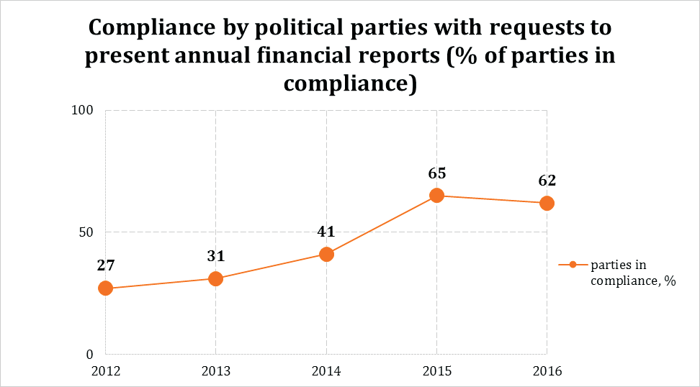
According to the latest monitoring report presented by Promo-LEX Association in May 2017 for the 2016 fiscal year, until 31 March 2017, only 23 of 45 political parties registered with MoJ, submitted annual reports to the competent authority. Other 5 political parties submitted the annual financial statements after the deadline.
Besides the fact that many political parties didn’t submit their financial reports, other common or significant errors/mistakes and infringements of reporting regulations in 2016 refers to:
- presentation of incomplete information or data in the reports;
- lack of information with regard to some obvious costs (for example, offices maintenance costs were not included, although the parties declared that owns or rented offices);
- infringement of the article 32 of the CEC Regulation on political parties’ financing - amount of cash donation exceeded the average monthly salary per economy made by an individual to a political party. According to the CEC decision no. 945 from June 6, 2017 on the financial reports of the political parties for the 2016 period, a number of 11 parties admitted such an infringement; also, according to the monitoring report realized by Promo-LEX, the cash donations collected in 2016 with the infringement of the CEC Regulation amounted MDL 11,087,848 (approx. Euro 502,850.24, the amount is calculated based on the data that was available from 4 political parties). In this context, there should be mentioned that the respective provision of the CEC Regulation was subject to legal control and on September 30, 2016 was declared illegal by the decision of the Court; the decision was also upheld by the Court of Appeal on 2 May 2017, but although this decision is final and enforceable, it is not irrevocable and therefore CEC decided to return to it after an irrevocable decision will be made by the Supreme Court of Justice;
- misinterpretation of some of the finance reporting regulations – for example, none of the parties submitted to the CEC by January 15, 2017 their semi-annual financial reports for the second semester of 2016, as it is requested by the article 29(1) of the Law on political parties. CEC did not take any measure with regard to this infringement and interpreted this issue based on the CEC Regulation (article 65), which has a different reading than as it is provided in the law.
Speaking about the election campaign financing, in order to understand the specific problems encountered during election periods, a close look at the financing of 2016 Presidential elections would be helpful.
The Electoral Code, article 38(1) provides that political parties, electoral blocs and independent candidates in parliamentary elections, have the obligation to present to the CEC within 3 days of opening the special account "Electoral Fund" and then once every two weeks a report on money earned and expenditure incurred in the campaign, both electronically and as hard copy, signed by responsible persons. It can be noted that, compared to political parties, during election campaigns the candidates seem to understand better and accept easier the reporting requirements stipulated in the Electoral Code. Thus, out of 12 candidates engaged in the Presidential competition, 11 of them reported on time, in both the first and second rounds of the election. According to the final reports for the first and second rounds submitted by 11 election candidates to the CEC, the total revenue declared for the period of 30 September – 11 November 2016 amounts to MDL 59 426 475 and the expenses to MDL 59 186 748. The total amount of declared revenue collected by all parties reached only 90.32% of the threshold established by CEC for a single election candidate. None of the candidates exceeded the maximum threshold established by the CEC of MDL 65 797 539 (approx. Euro 2,984,015.37). In this context, it should be noted that legislation provide spending limits only for electoral campaigns, but not for regular annual activities of political parties.
According to the final financial statements of the election candidates engaged in the Presidential race, the largest share of declared expenses went to advertising – 89%, followed by costs for promotional materials – 5%, transport – 2%, expenses for meetings and events – 2%, expenses for delegating or detaching persons (volunteers/observers) – 1%; additional maintenance expenses – 0.3%, communications – 0.3%, and other expenses – 0.4%.
During 2016 Presidential elections, both international and national election observers closely monitored campaign financing. As it was stated by the OSCE/ODIHR Mission in its Final Report on 2016 Presidential elections in Moldova, “overall, the regulatory system and its implementation continues to be insufficient to ensure transparency, integrity and accountability of campaign finances, and did not enjoy public confidence”. Such an appreciation is grounded on a variety of problems that were observed in connection to the financing of the election campaign:
- One of the main findings of Promo-LEX Association with regard to 2016 election campaign financing in Moldova refers to the fact that not all the financial resources were declared to the CEC. Based on a civic monitoring methodology, Promo-LEX found that all 11 election candidates did not report completely the expenses incurred during campaign (round I and round II). The total unreported expenses amount to at least MDL 7 667 223 (approx. Euro 347,719.86). Detailed information on the unreported costs of the election candidates during the Presidential competition can be found on the webpage of Promo-LEX;
- OSCE/ODIHR also concluded that “while the assessments of the reports submitted before the first round were published before the first round election day, the second CEC audit report was not published before the run-off. This decreased the efficiency of campaign finance oversight, contrary to international obligations and good practice, and affected voters’ ability to make a fully informed choice”;
- The observers also concluded that “The legislation does not allow adequate time for effective oversight of financial reports, fails to provide proportionate sanctions for campaign finance violations during signature collection and the campaign, does not regulate finance and reporting requirements during the second round, and does not address third-party campaigning”;
- In Moldova donations from out-of-country sources of income are prohibited. In the context of heavy migration of Moldovans for living and working abroad, this restriction is disproportionate and impact directly on the freedom of expression and freedom of association of the citizens/voters, but also on the candidates’ ability to reach the support of their voters;
- According to international and national observers, CEC didn’t address proactively campaign finance violations and reacted only in response to complaints. Although Promo-LEX raised the attention of CEC to the discrepancies in the financial reports, the institution did not take any action.
A specific impact on the election campaigns in Moldova is made during the last years by the involvement or activation of foundations associated with political leaders. According to Moldovan legislation a foundation is a non-profit, non-political organization, which should not provide any political/electoral support to any candidate or political stakeholder. Still, in 2016 Presidential elections, two foundations associated with political leaders - “Edelweiss” Foundation of Vlad Plahotniuc and the “Renato Usatii” Foundation, through their activities and using the tool of image transfer, indirectly impacted the electoral image of two candidates (Marian Lupu, nominated by the Democratic Party and Dumitru Ciubasenco, nominated by Our Party/leader of the party is Renato Usatii). According to the final report of Promo-LEX on 2016 Presidential elections, the “Renato Usatii” Foundation donated over MDL 500 000 for the development of some villages and towns in the Republic of Moldova, while “Edelweiss” Foundation installed playgrounds and created mobile pediatric offices.
The use of administrative resources is another characteristic phenomenon for the Moldovan elections. Article 48¹(5) of the Contravention Code is defining the sanction for the use of administrative resources, but nevertheless, there are no concrete examples of contraventions established so far based on this type of irregularity. Given the information provided by the General Inspectorate of Police, by February 2017, no contravention and criminal cases were documented based on the aforementioned article.
The graph included bellow shows in dynamics the number of cases of use of administrative resources, compared to the phenomenon of electoral gifts offered by the election candidates. As it can be read, while the number of cases of electoral gifts documented by Promo-LEX monitors is constantly decreasing, the use of administrative resources has a trend that is rather positive.
In the context of the last nationwide elections, Promo-LEX observers found at least 65 confirmed cases of use of administrative resources by election candidates.
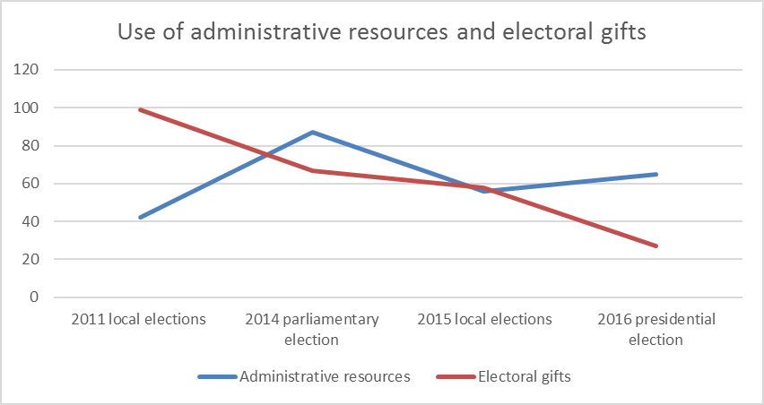
In general, administrative resources were mainly used by the representatives of the local public administration in support of the candidates from the parties they belonged to or sympathized with.
The most common forms of administrative resources used are: campaigning during working hours; meetings with civil servants organized during working hours; public servants involved in campaign activities during working hours; use of government means of transportation; and campaigning on public authorities’ premises.

RECOMMENDATIONS
- The capacities of the Central Electoral Commission and its technical expertise should be consolidated. It should be given sufficient authority and resources to conduct effective oversight of political finances in Moldova;
- The ceiling of membership fees and donations collected annually should be reduced from 0.3% of the state budget revenues to 0.2%, in order to prevent undue influence of the private sector on political parties;
- The threshold of donations from individuals and legal entities to election candidates and political parties should be reduced in accordance to the average standards of living;
- The legislator should amend the LPP No. 294 by excluding the prohibition of electoral campaigns and political parties funding by Moldovan citizens who are temporarily abroad;
- The legislator should amend the Law on Political Parties by introducing the obligation of paying membership fees and the periodicity of payment;
- The legislator should introduce Article 87(a) of the CEC Regulation on financing political parties into the Law on Political Parties, so that from 2018 the CEC would have the right to suspend the transfer of state funds in the case of parties’ failure to pay the membership fees;
- Amend the LPP No. 294 so it will explicitly provide the deadlines for the financial reports that are to be presented for each semester and annually;
- The legislator should consider introducing more diverse and severe sanctions for non-compliance with the reporting requirement, both for the political parties and election candidates;
- Annual auditing should be imposed for political parties whose annual income or expenses exceeded one million MDL, in line with the GRECO recommendations;
- Introduce financial incentives amounting to 20% of the total amount of subsidies for political parties to promote gender equality;
- CEC is recommended to run public information campaigns focusing on political parties and campaign funding in order to increase the transparency of political finances;
- The Centre for Continuous Electoral Training (CCET) shall organize training sessions for political parties’ representatives, focused on the presentation of the amendments to the legislation, problems and difficulties encountered by political parties in their financial management etc.;
- Paid electoral advertising should be prohibited and free electoral advertising in public media institutions should be used for election debates, broadcasting campaign meetings and other activities.

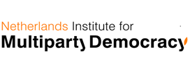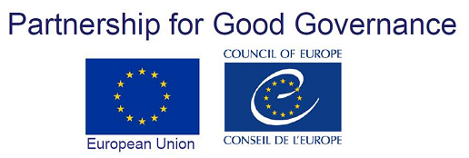
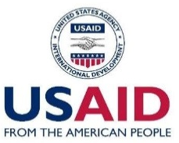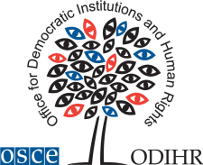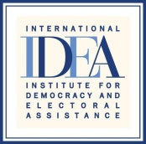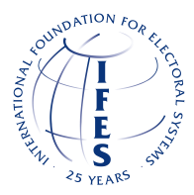

Disclaimer: The views and opinions expressed in this report are those of the author and do not necessarily reflect the official policy or position of SAOG, Council of Europe, International IDEA, IFES, NIMD, OSCE-ODIHR, or TI Georgia.
Third Evaluation Round. Evaluation Report on Moldova Transparency of Party Funding, https://rm.coe.int/16806c9a94
In the 2011 Report on the general local elections, OSCE/ODIHR pointed out that “Oversight of campaign financing is insufficiently developed, lacking precision and enforcement mechanisms. Contestants appeared not to have treated their reporting responsibilities diligently and the comprehensiveness of reporting was questioned by many stakeholders.” - http://www.osce.org/odihr/elections/85409?download=true (page 4)
Funding of Political Parties and Election Campaigns. A Handbook on Political Finance. International Institute for Democracy and Electoral Assistance (IDEA), Stockholm 2014, p. IV.
According to the official information submitted by the Ministry of Foreign Affairs and European Integration (MFAEI), collected from the diplomatic missions and consular offices and provided by the authorities of the host states, the number of Moldovan citizens leaving/working abroad is 805,509 persons. This information was provided by the MFAEI in the run-up to the presidential election of 30 October 2016 for estimating the number of potential voters. https://promolex.md/wp-content/uploads/2016/10/Raport-electoral-2016_3_eng.pdf (p.14)
Venice Commission Guidelines and Report on the Financing of Political Parties, http://www.osce.org/odihr/37843?download=true
Promo-LEX Association, Study “Strategies, Practices and Tools for financing political parties in Moldova”, https://promolex.md/wp-content/uploads/2016/04/doc_1459254551.pdf, page 23
OSCE/ODIHR Election Observation Mission Final Report on 2016 Presidential Elections in Moldova.
The parties that had not complied with this provision, particularly acceptance/reporting of cash donations exceeding MDL 5,050, risked being sanctioned and/or forced to pay the amount exceeding the ceiling to the state budget or to reimburse it.
Article 38(2) letter d) of the Electoral Code stipulates that CEC shall establish the general threshold for funds that can be transferred on the “Electoral Fund” account, using as a basis a coefficient multiplied by the number of voters from the constituency where the elections are held.
Financing of the Electoral Campaign for the Presidential Elections in the Republic of Moldova, https://promolex.md/wp-content/uploads/2016/11/Raport-financiar-26.11.2016-english.pdf

