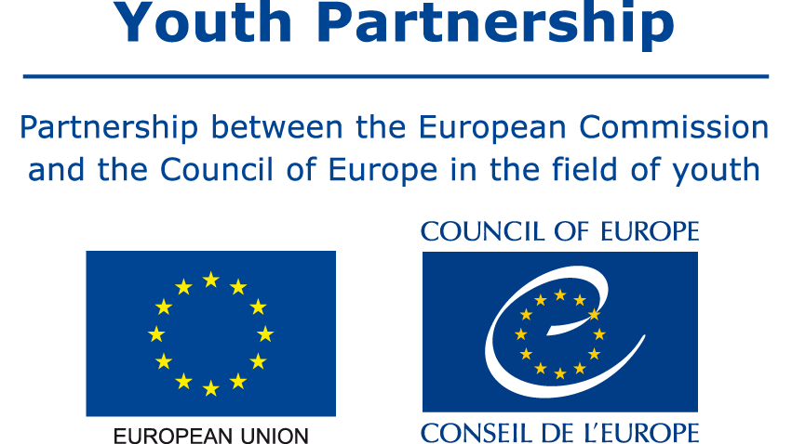

Country sheet

on youth Work

in (Country)

Last updated: xx.xx.xxxx
Author: XXX
Updated by: XXX

The content of this document, commissioned by the EU-CoE youth partnership, is the sole responsibility of the author and does not necessarily reflect the opinion of either of the partner institutions (the European Union and the Council of Europe).

Contents

1. Strategic and legislative framework of youth work in the country 2
2. Funding youth work 3
3. Forms and examples of youth work in your country 4
4. Structures, actors and levels in youth work provision 5
4.1 State structures deciding on or providing youth work in your country? 5
4.2 National or local youth councils 5
4.3 Youth and youth work NGOs 5
4.4 Other relevant actors 5
5. Recognition 6
6. Quality standards 7
7. Knowledge and data on youth work 8
8. European and International dimension of youth work in the country 9

Strategic and legislative framework of youth work in the country
Is there a policy and/or legislative framework guiding youth work in your country? How does it define the purpose and value of youth work?
In the absence of such formal acts, how does the state define the purpose and value of youth work? Who is youth work meant for (all young people or specific groups?).

Funding youth work
What is the national or local budgetary allocation for youth work in your country? If there are specific programmes supporting youth work, what is their main aim and budget?

Forms and examples of youth work in your country
How is youth work happening in your country, for example, is it youth centre-based, online youth work, outreach youth work, open youth work, are NGOs or local authorities the main providers etc
Are there specific forms the state encourages or supports more and why?

Are there any established or new effective youth work practices you would like to share?
Do you have examples of digital/online youth work developing?

Structures, actors and levels in youth work provision

State structures deciding on or providing youth work in your country?

Which government levels are involved? If there are separate agencies, please mention them here. Please include numbers of people or entities where data is available

National or local youth councils

Youth and youth work NGOs

Other relevant actors

Recognition
According to the definition of recognition there is self, social, formal and political recognition of youth work and of youth workers (professionals or volunteers). What is the situation in your country on these different dimensions of recognition of youth work?
Is there any formal validation system of non-formal education and learning in youth work contexts implemented in your country?
Is your country involved in any European or applying any national initiatives to support youth work (for example, Council of Europe quality label, Erasmus + Youthpass, European Youth Capitals, Youth Friendly Cities, others)?

Quality standards
Are there any competence frameworks or quality standards guiding youth workers and youth work activities in your country? Is there any structure involved in overseeing their implementation? If not, what guides the quality aspects of youth work?

Knowledge and data on youth work
Is there any research or a system of continuous documentation and study of youth work in your country? For example, has there been any research on the tradition and developments of youth work (many have been published in the History series part of the Youth Knowledge Books)

If data is available, how many young people benefit from youth work in your country on an annual basis? How many youth workers are employed and how many are volunteering in your country?

What are the current debates and open questions/discussions around youth work in your country?
Please include any available sources of information on youth work in your country

European and International dimension of youth work in the country
Is there an international dimension to youth work policy in your country (for example, is your country implementing the Council of Europe Recommendation CM/Rec(2017)4 of the Committee of Ministers to member States on youth work, or relevant EU Council Conclusions?
What international youth work opportunities are present in your country for young people and for youth workers? What programmes are promoted? Which opportunities for exchange of experiences among youth work practitioners are included?

