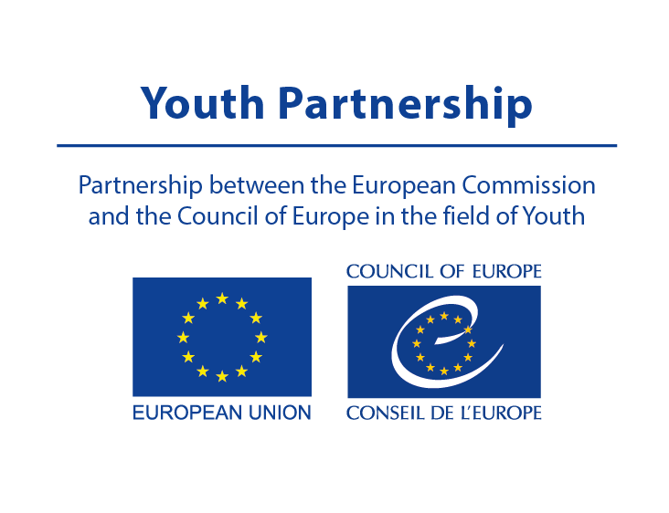

POOL OF EUROPEAN YOUTH RESEARCHERS (PEYR)
APPLICATION FORM

Please complete this form and send it, together with other supporting documents
(CV and writing sample) to youth-partnership@partnership-eu.coe.int

Deadline for applications: 20 October 2023

First name:

Last name:

E-mail:

Occupation:

Country of residence:

Nationality/-ies:

English written and oral proficiency:

If you are affiliated to one or more research institutions, please name them and indicate your affiliation and their address:

What is your experience in knowledge and research about young people’s lives, interests, aspirations and challenges?

What is your experience in developing knowledge-based youth policies at European and/or national level?

What is your experience in developing knowledge about youth work?

What are the topics you have covered in your research in the past year?

What is your motivation for being a member of PEYR?

Please include below links of up to five relevant research projects or publications to which you contributed:

