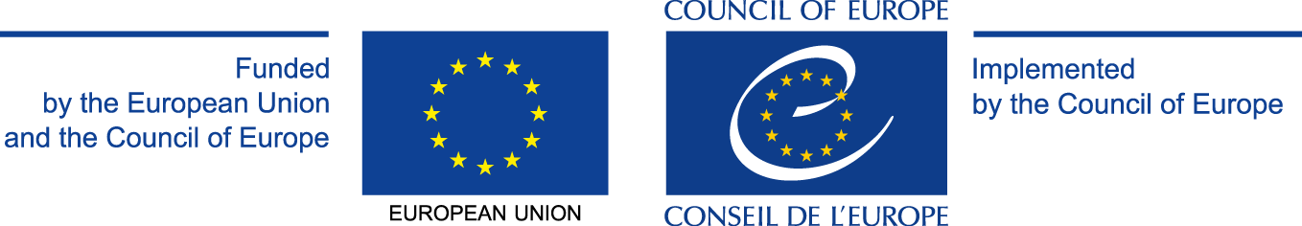

Appendix I

APPLICATION FORM

THIS FORM MUST BE COLLECTED AND SENT BY
THE IMPLEMENTING PARTNER IN CHARGE OF SUBMITTING THE PROJECT TO THE COUNCIL OF EUROPE

GRANT AWARD PROCEDURE

Human Rights and Democracy in Action
EU/CoE Joint Programme for international cooperation projects

2016 EDC/HRE PPS 2

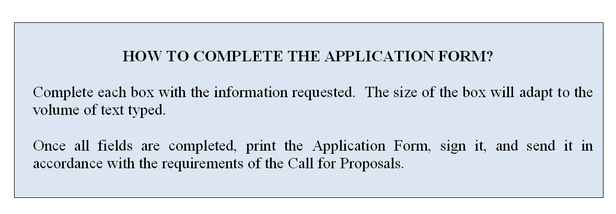

- IMPLEMENTING PARTNER IN CHARGE OF THE SUBMISSION OF THE PROJECT PROPOSAL
Official name ►
Legal form ►
Full address ►
Website (if any) ►
Name of the person(s) entitled to enter into legally binding commitments on behalf of the implementing partner (indicate name and position) ►
- CONTACT DETAILS
Contact person ►
Position of the contact person ►
E-mail address ►
Phone number ►
- BANK DETAILS
Name of the bank ►
Address of the bank ►
Account holder name ►
Full account number (including bank codes) ►
IBAN (or BIC Code) ►

1A. IMPLEMENTING PARTNER N 2
Official name ►
Legal form ►
Full address ►
Website (if any) ►
Name of the person(s) entitled to enter into legally binding commitments on behalf of the implementing partner (indicate name and position) ►
2A. CONTACT DETAILS
Contact person ►
Position of the contact person ►
E-mail address ►
Phone number ►
3A. BANK DETAILS
Name of the bank ►
Address of the bank ►
Account holder name ►
Full account number (including bank codes) ►
IBAN (or BIC Code) ►

- PROPOSED ACTION

- Project overview: Please provide a description of the project as follows:
Title ►
Objective(s) ►
Activities ►
Partner countries (NB: from 3 to 8, with at least three of the countries being a member of the EU or, where the number of states is less than six, at least half of the countries being a member of the EU) ►
Participating organisations/institutions in each country and their roles (ex. coordinator, participant, implementing agency) ►
Expected results ►
The Council of Europe Tool to be used:► | LOT 1: The Council of Europe Framework of Competences for Democratic Culture ☐  OR  LOT 2: Outcomes produced in the framework of the “Human Rights and Democracy in Action” Programme (See outcomes 2013 - 2015) ☐  Choose an item.

- Appropriateness and relevance of the action in accordance with the Charter
Please explain how the project will contribute to the aims and objectives agreed by the Council of Europe member states in the Charter on citizenship and human rights education (in the primary, secondary (lower and higher) and initial vocational education and training levels), in accordance with the present Call for Proposals. Please note in particular that the grants will fund projects designed to contribute to the sustainable development and promotion of education for democratic citizenship and human rights education. ▼

This programme cycle will focus on:

LOT 1: Putting into practice the Council of Europe Framework of Competences for Democratic Culture.

The participating countries are invited to demonstrate how competences for democratic culture are reflected in their respective education strategies, how they are put into practice in their education systems and how the development of such competences could be further strengthened in different contexts through teacher training, curriculum development, learners assessment and other relevant strategic actions, based on the Council of Europe Framework of Competences for Democratic Culture. Information on the Framework is available at the following address: www.coe.int/competences.

LOT 2: Consolidating the outcomes produced so far in the framework of the “Human Rights and Democracy in Action” Programme (See outcomes 2013 - 2015).

In particular, support will be provided to the translation, adaptation, further development, dissemination and piloting of the above-mentioned tools and supporting their introduction in the education systems of the participating countries.

- Potential impact on educational policy and practice in the participation countries
Please describe how the project will impact the educational policies and practices in the participating countries, including possible ways of evaluating such impact (1-2 years after the project) ▼

- Potential for awareness raising at national and/or international level
Please describe how the project will contribute to increased visibility and awareness of the role of citizenship and human rights education for the future of democratic societies and specify what visibility material is expected to be produced (ex. video and/or audio products, coverage on relevant websites, the use of social media, coverage in specialised magazines, other publications) ▼

- Participation of NGOs, youth organisations/associations, parents associations in the project design and implementation
Please describe how non-governmental organisations (national or international), youth organisations/associations and parents associations will contribute to the project design and implementation. In particular, you might wish to provide an indicative list of organisations, number of organisations, methodology for cooperation, your previous experience with respect to cooperation and potential for sustainability for such cooperation. ▼

- Participation of the States party to the European Cultural Convention, which had not previously taken part in this Programme, and Kosovo*
Please indicate whether one or more of the following countries are among the partners for the present project proposal:
1. Andorra 2. Armenia 3. Azerbaijan 4. Belgium 5. Bosnia and Herzegovina 6. Bulgaria 7. Czech Republic 8. Denmark 9. Estonia 10. Germany 11. Holy See 12. Iceland 13. Italy 14. Kazakhstan 15. Latvia 16. Liechtenstein 17. Luxembourg 18. Malta 19. Monaco 20. Netherlands 21. Norway 22. Portugal 23. Republic of Moldova 24. San Marino 25. Serbia 26. Slovak Republic 27. Slovenia 28. Switzerland 29. “the former Yugoslav Republic of Macedonia” 30. Turkey 31. Ukraine 32. Kosovo* ▼

 | - Action plan
 | Briefly present your plan for the implementation of activities until 30 September 2017 ▼
Activity |  | 2016 |  |  | 2017
Month |  | 10 | 12 | 12 | 1 | 2 | 3 | 4 | 5 | 6 | 7 | 8 | 9

- OPERATIONAL CAPACITY OF THE IMPLEMENTING PARTNERS
Indicate below how the implementing partners intends to implement the proposed action (where applicable, indicate the involvement of third parties including providers) ▼

- CO-FUNDING
Please explain your available resources and needed resources to implement the project. Indicate below how the implementing partner intends to contribute to the project (either by way of its own resources or by contribution from third parties). Co-financing may take the form of financial or human resources, in-kind contribution or income generated by the action.

Remark concerning the budget table (appendix II): The budget will not cover operating costs of national administration personnel assigned to the project, but only direct, eligible costs such as travel, hotel, special costs associated to meetings (venue, interpretation, stationery, secretariat, etc.). Exception may be made for contracting national experts (working language English or French) to help planning and coordinating project activities and inasmuch as non-governmental entities (national or international) are called in to participate in the project, for expertise and research, with standard fees being accepted as part of the budget. Please submit one budget table per partner country. ▼

- DECLARATION
I, the undersigned, authorized to represent the implementing partner, hereby certify that the information contained in this application is correct and that the organisation has not received or applied for any other Council of Europe funding to carry out the action which is the subject of this grant application.

I certify on my honour that the organisation is not in one of the situations which would exclude it from taking part in a Council of Europe grant award procedure, and accordingly declare that the organisation:

a. has not been sentenced by final judgment on one or more of the following charges: participation in a criminal organisation, corruption, fraud, money laundering;

b. is not in a situation of bankruptcy, liquidation, termination of activity, insolvency or arrangement with creditors or any like situation arising from a procedure of the same kind, or is not subject to a procedure of the same kind;

c. has not received a judgment with res judicata force, finding an offence that affects its professional integrity or constitutes a serious professional misconduct;

d. does comply with its obligations as regards payment of social security contributions, taxes and dues, according to the statutory provisions of the country where it is established.

- SIGNATURE
Name / First name of the Signatory ►
Title of position in the organisation of the implementing partner submitting the proposal ►
Place of signature ►
Date of signature ►
Signature and official stamp of the implementing partner submitting the proposal ►

Repeat this part as often as is required to include all the implementing partners.
*All references to Kosovo, whether to the territory, institutions or population, in this text shall be understood in full compliance with United Nations Security Council Resolution 1244 and without prejudice to the status of Kosovo.

